AN INTERNSHIP REPORT IN MARKET RESEARCH & GENERAL MANAGEMENT IN IMZAK ORGANICS

Submitted In partial fulfilment for the award of the degree of

BACHELOR’S OF BUSINESS ADMINISTRATION IN INTERNATIONAL BUSINESS

Session (2023-2026)


Submitted by,

Md. Aatir Usmani
REGISTRATION NO. – 23363302036

ST. XAVIER’S COLLEGE OF MANAGEMENT & TECHNOLOGY, PATNA
NAAC Accredited with B++ Grade (1st Cycle)

Affiliated to

ARYABHATTA KNOWLEDGE UNIVERSITY, PATNA
TABLE OF CONTENT

GUIDE’S CERTIFICATE
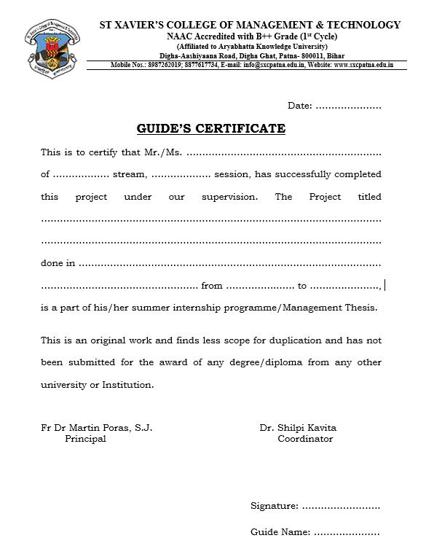

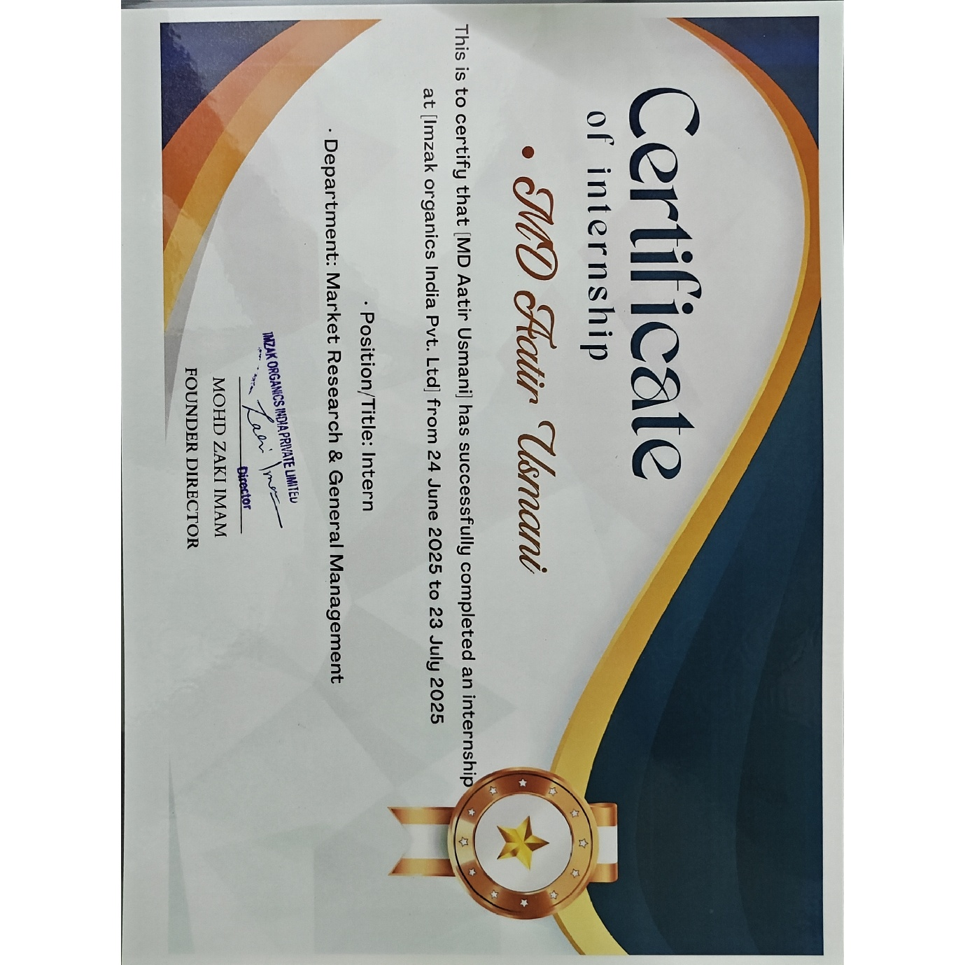
INTERNSHIP CERTIFICATE

DECLERATION

This is to declare that, I Md. Aatir Usmani student of St. Xavier's College of Management & Technology, Patna, Bihar, BBA(IB), Batch 2023-26, has given original data and information to the best of my knowledge in the internship report titled "Market Research & General Management at IMZAK Org. Patna" is a record of independent and original work carried out by me under the guidance and supervision of Mr. Bidyanand Chaudhary towards the partial fulfilment of requirement for the BBA(IB) course.
I also declare that no chapter of this internship report in whole or in part has been incorporated in this report from any earlier work done by others or by me. However, extracts of any literature which has been used for this report has been duly acknowledged providing details of such literature in the reference.
Md. Aatir Usmani
BBA(IB) 2023-26

ACKNOWLEDGEMENT

I would first like to extend my heartiest gratitude to our Principal Fr. Martin Poras and our coordinator and internship guide Mr. B.N. Chaudhary, Ms. Kalpana Kumari and Dr. Shilpi Kavita who have given their valuable time.
I would also like to express my sincere gratitude to IMZAK Organics for providing me with the opportunity to intern at their esteemed organization. The experience has been invaluable and has significantly contributed to my personal and professional growth. I am deeply appreciative of the guidance, support, and mentorship provided by the entire team during my tenure.
I extend my heartfelt thanks to the CEO ZAKIR IMAM for their continuous support and encouragement throughout my internship. Their insights and expertise have been instrumental in shaping my understanding of the MARKET RESEARCH & GENERAL MANAGEMENT.
Furthermore, I am grateful to every team member at IMZAK Organics who generously shared their knowledge and offered guidance during my internship. The collaborative environment and the opportunity to work alongside such a dedicated team have been enriching
Lastly, I am thankful to the entire organization for their warmth, hospitality, and for providing me with a platform to apply my skills and learn from practical experiences. This internship has been a transformative learning journey, and I am deeply appreciative of the chance to be a part of the IMZAK Organics team.

Md. Aatir Usmani
BBA(IB) 2023-26
St. Xavier's College of Management & Technology, Patna

ABSTRACT

This internship report provides a comprehensive overview of the operations and business activities of IMZAK Organics, a leading private organization specializing in natural honey brand in Bihar, India. IMZAK Organics has established a prominent presence in the honey industry. The report delves into the core aspects of the company's operations, focusing on both the distribution and manufacturing sectors.
The report commences by elucidating IMZAK Organics role as a distributor of honey and honey related products across the World, highlighting their extensive product range and market reach. It explores the various challenges faced in the distribution process, including supply chain management, market demand fluctuations, and regulatory compliance. Through this analysis, a nuanced understanding of the intricacies involved in the distribution of honey and honey related products across the World is provided.
Additionally, the report offers a detailed insight into IMZAK Organics manufacturing division, situated in Phulwari Sharif, Bihar. The manufacturing plant boasts a robust capacity, capable of producing thousands unit annually. The report meticulously examines the manufacturing processes, quality control measures, and technological advancements implemented in the production of honey and honey related products. Special emphasis is placed on the innovative approaches adopted by the company to enhance manufacturing efficiency and product quality.
Furthermore, the report sheds light on the regulatory landscape governing the honey industry in Bihar. It discusses the compliance requirements, licensing procedures, and standards set forth by regulatory authorities. An analysis of IMZAK Organics adherence to these regulations is provided, underscoring the organization's commitment to maintaining ethical and legal standards in its operations.
The internship experience at IMZAK Organics also provided an opportunity to gain practical insights into the challenges faced by the organization. This report explores the internship journey, highlighting the hands-on experiences, learning opportunities, and professional growth achieved during the tenure. It reflects on the valuable skills acquired, ranging from market research and data analysis to interpersonal communication and problem-solving abilities.
In conclusion, this internship report offers a holistic perspective on IMZAK Organics operations, encompassing both the distribution and manufacturing facets of their honey business. By delving into the complexities of the industry, regulatory compliance, and the practical aspects of the internship, this report serves as a comprehensive resource for understanding the dynamics of honey businesses in Bihar.

EXECUTIVE SUMMARY

This internship report presents an analytical overview of the internship experience at IMZAK Organics, a company specializing in sustainable and honey-based products. The primary objectives of the internship were to conduct in-depth market research, evaluate consumer preferences, analyse competitor strategies, and contribute to the general management of the company’s operations. The internship aimed to enhance brand positioning, streamline internal processes, and strengthen IMZAK’s market presence in the organic products sector.
Key activities involved data collection on consumer behaviour, market trends, and product performance, sales, along with active participation in inventory coordination, vendor communication, and production management. Various research methodologies such as SWOT analysis, survey-based market assessment, and competitive benchmarking were utilized to derive insights for strategic decision-making.
Findings indicated a growing consumer inclination toward sustainable and health-oriented products, presenting opportunities for IMZAK Organics to diversify its offerings and expand distribution channels. The study also highlighted the potential of improved supply coordination to optimize business performance.
The report concludes with recommendations focusing on enhancing market outreach, adopting data-driven marketing strategies, and fostering operational efficiency. These initiatives are expected to strengthen IMZAK Organics’ competitive advantage and drive sustainable business growth in an evolving organic product market.

Keywords:
Market Research, IMZAK Organics, Consumer Analysis, General Management, Sustainable Business, Competitive Strategy

WEEKLY OVERVIEW OF INTERNSHIP ACTIVITIES

Week | Date | Day | Work Done
WEEK 1 | 24-06-2025 | Tuesday | 1. Study about the organization.  2. Called the printing company and talked about the details.
WEEK 1 | 25-06-2025 | Wednesday | 1. Photoshoot of the products.  2.Material Handling
WEEK 1 | 26-06-2025 | Thursday | 1. Market visit (khadi Mall)  2. Done Sales of Honey Worth Rs. 14,000/-  3. Gather Info of the Market
WEEK 1 | 27-06-2025 | Friday | 1. List out the Companies for New Product (Raw Materials)  2. Created Company Catalogue of Products

Week | Date | Day | Work Done
WEEK 2 | 30-06-2025 | Monday | 1. Product handling  2. Machine operating
WEEK 2 | 01-07-2025 | Tuesday | 1. Create google form  2. Contacting vendors
WEEK 2 | 02-07-2025 | Wednesday | 1. Contact vendors
WEEK 2 | 03-07-2025 | Thursday | 1. Order placement for Raw Materials  2. Gulkand vendor search
WEEK 2 | 05-07-2025 | Saturday | 1. Supervision at the Factory  2. Learned about machineries  3. Learn to check refractometer

Week | Date | Day | Work Done
WEEK 3 | 08-07-2025 | Tuesday | 1. Visited Upendra Maharati Shilp  2. Raw Material Ordering
WEEK 3 | 09-07-2025 | Wednesday | 1. Sales Target Achievement 2. Google Form Review
WEEK 3 | 10-07-2025 | Thursday | 1. Packaging & Production
WEEK 3 | 12-07-2025 | Saturday | 1. Photoshoot  2. Advertisement Creation

Week | Date | Day | Work Done
WEEK 4 | 14-07-2025 | Monday | 1. Visited Upendra Maharati Shilp  2. Visited Khadi Mall  3. Visited Vikas Bhawan  4. Visited Bihar Vidyapeeth
WEEK 4 | 15-07-2025 | Tuesday | 1. Supervision at Factory
WEEK 4 | 16-07-2025 | Wednesday | 1. Editing of Advertisement
WEEK 4 | 17-07-2025 | Thursday | 1. Advertisement Creation  2. Video Editing
WEEK 4 | 18-07-2025 | Friday | 1. Set up Stall in Bihar Industrial Association Building Day 1
WEEK 4 | 19-07-2025 | Saturday | 1. Set up stall in Bihar Industrial Association Building Day 2

Week | Date | Day | Work Done
WEEK 5 | 21-07-2025 | Monday | 1. Label Design  2. Add creation
WEEK 5 | 22-07-2025 | Tuesday | 1. Label Design  2. Add creation
WEEK 5 | 23-07-2025 | Wednesday | 1. Created Slim Honey (new product)

INTRODUCTION

1.1 Background of the Study
Internship is an arrangement by which a student works in a company for a limited time period to gain practical experience and acquire knowledge about different activities of the organization. The internship study focused on market research and general management at IMZAK Organics, a growing enterprise engaged in producing and marketing sustainable, honey-based, and herbal products. The duration of the internship was from 24/06/2025 to 23/07/2025. IMZAK Organics, being a part of the competitive organic product industry, emphasizes quality, innovation, and sustainability to meet the evolving preferences of health-conscious consumers.
The internship study aimed to analyse the company’s market position, understand consumer behaviour, evaluate competitor strategies, and contribute to the overall managerial operations of the organization. This included conducting surveys, gathering and interpreting market data, identifying potential areas for product expansion, and assisting in daily administrative and coordination tasks. I was also involved in assessing sales trends, customer feedback, and distribution strategies to determine how IMZAK Organics could strengthen its market presence.
By understanding the company’s existing marketing and management practices, the study sought to provide insights that could help enhance brand visibility, operational efficiency, and customer engagement. This research not only contributed to IMZAK Organics’ strategic goals but also offered valuable practical experience in applying business concepts to real-world challenges in the organic and sustainable product sector.

1.2 Background of the Company
IMZAK Organics is a leading manufacturer and supplier of natural honey based in Bihar, India. Established in 2022, the company was founded with the vision of delivering pure, healthy, and chemical-free honey to consumers across India. Rooted in Bihar’s rich agricultural and cultural heritage, IMZAK Organics has quickly emerged as a trusted name in the organic products industry, known for its commitment to quality, authenticity, and sustainability.
The company works closely with local farmers and beekeepers to source honey from the finest floral regions, including mustard, eucalyptus, and sunflower fields. By maintaining strong relationships with these communities, IMZAK Organics ensures ethical sourcing and promotes sustainable livelihoods. With a team of 5 to 8 dedicated professionals, the company oversees every stage of production — from nectar collection to bottling — ensuring that each jar of honey reflects purity and freshness.
IMZAK Organics takes pride in its raw, unfiltered, and unpasteurized honey, which retains its natural enzymes, minerals, and vitamins. Free from pesticides, antibiotics, and artificial sweeteners, the honey produced is both safe and nutritious for consumers. The company’s state-of-the-art laboratory is equipped with modern testing facilities to monitor purity, nutritional value, and flavour consistency, guaranteeing adherence to the highest quality standards.
The production process at IMZAK Organics involves several careful steps — collection of nectar, extraction of honeycomb, separation of honey and wax, filtration, and eco-friendly bottling. Each stage is executed with precision and care to ensure minimal environmental impact and maximum product integrity.
IMZAK Organics operates its manufacturing unit at Nousha Road, Phulwari Sharif, Patna, Bihar. The factory houses two production lines designed for efficient and hygienic honey processing. The facility is equipped with essential machinery such as honey filters, heaters, refiners, cooling and heating systems, and a refractometer for testing the moisture content and quality of honey.
The unit also includes a dedicated warehouse for raw material and finished goods storage, ensuring smooth logistics and inventory management. With a production capacity of up to 1,000 liters per day, the factory can meet growing market demand while maintaining strict quality control measures.
A small but skilled team of 3 to 5 workers oversees key operations including refining, filtering, cooling, testing, packaging, and labelling. The facility follows FSSAI-certified safety and hygiene standards, ensuring that every product meets regulatory and consumer expectations for purity and safety.
Today, IMZAK Organics serves customers across India, expanding its footprint through both direct sales and partnerships with distributors and retailers. The company continues to uphold its mission of promoting natural wellness through high-quality honey and honey-based products, solidifying its position as a growing leader in the organic and sustainable product market.

1.3 Objective of the Study
- To understand the functioning of a natural honey and honey-based products manufacturing company.
- To explore strategies to enhance overall general management.
- To understand the market for better sales performance and improved market insight.

1.4 Significance of the Study
The significance of the study can be summarized as follows:
- This internship report provides an opportunity to understand the functioning and management of IMZAK Organics, including production, inventory, and distribution of honey and honey-based products.
- It offers practical exposure to general management and market research, allowing insights into operational decision-making, market trends, and consumer preferences in the natural and organic products industry.

1.5 Chapterization
- Introduction: This section provides an overview of my internship experience, including details about IMZAK Organics and the objectives I aimed to achieve during the internship.
- Company Profile: This section presents background information about IMZAK Organics to give readers a comprehensive understanding of the organization, its operations, and its products.
- SWOT Analysis: The SWOT analysis evaluates the internal and external factors affecting the company, highlighting its strengths, weaknesses, opportunities, and threats.
- Suggestions & Conclusion: This section summarizes the overall internship experience, reflecting on the insights gained in general management and market research, and offers suggestions for operational and market improvements.

1.6 Limitation
- Challenges in Market Research: Collecting accurate and comprehensive data for market research was sometimes difficult, limiting the depth of insights.
- Interpersonal Difficulties: Some interactions with people outside the organization were uncooperative or rude, which occasionally hindered smooth data collection.
- Focus on General Management: My supervisor primarily emphasized general management tasks, which limited the opportunities to apply and enhance my market research skills.
- Sales Target Challenges: Achieving sales targets proved to be difficult due to market competition and consumer behaviour factors.
- Time Constraints: The brief duration of the internship limited the extent to which I could explore and contribute to all aspects of the organization’s operations.

COMPANY

2.1 History of IMZAK Organization
IMZAK Organics was established in 2019 with a simple yet powerful vision — to bring pure, natural, and chemical-free honey products to the Indian market. The foundation of the company was laid by a group of passionate entrepreneurs who shared a common belief in sustainable living, environmental protection, and the promotion of natural wellness. What began as a small beekeeping initiative in rural Bihar soon transformed into a rapidly growing enterprise recognized for its commitment to quality, purity, and community empowerment.
The idea for IMZAK Organics was born out of a realization that the honey industry in India was flooded with adulterated and processed products that had lost their natural essence. The founders saw an opportunity to create a brand that not only delivered authentic honey directly from the hives but also contributed to the livelihoods of local beekeepers and rural communities. With a focus on transparency and trust, the company started working directly with farmers and apiculturists, training them in modern and ethical beekeeping techniques while ensuring fair trade and consistent income.
In its early years, IMZAK Organics operated on a small scale, collecting raw honey from local farms and selling it through regional distributors. However, as demand grew, the company began investing in modern extraction, filtration, and packaging technology, enabling it to maintain large-scale production without compromising on natural quality. This combination of traditional craftsmanship and modern science became the hallmark of IMZAK’s identity.
Over time, IMZAK Organics expanded its product range beyond traditional honey to include flavoured, herbal, and infused varieties such as Tulsi Honey, Jamun Honey, Ginger Infused Honey, and Turmeric Honey, catering to the growing demand for functional foods and Ayurvedic health products. It also launched superfood items like Bee Pollen, Kashmiri Saffron, Amla Honey Murabba, and Shilajit Honey Sticks, offering consumers a natural alternative to processed energy and wellness supplements.
The company’s growth has been guided by its core values of purity, sustainability, and social impact. IMZAK Organics partners with numerous small-scale beekeepers across Bihar, Jharkhand, and Uttar Pradesh, ensuring that they receive fair compensation and ongoing technical training. This initiative has not only improved the quality of honey production but has also created employment opportunities in rural areas, particularly for youth and women.
In addition to its social focus, IMZAK Organics has made environmental sustainability a key part of its mission. The company encourages eco-friendly beekeeping practices, the planting of nectar-rich trees and flowers, and protection of pollinators, which are crucial for biodiversity and agriculture. The company’s operations are designed around a zero-waste principle, where even by-products like beeswax and pollen are reused to create skincare products and organic candles.

Within just a few years, IMZAK Organics has evolved from a local startup into a recognized natural brand with a growing presence across India. Its products are now available both through offline retail networks and online marketplaces, and the company continues to build its reputation for authenticity and trust. The introduction of attractive, eco-conscious packaging and branding has further helped IMZAK connect with a younger generation of health-conscious consumers.
Today, IMZAK Organics stands as a symbol of how entrepreneurship, sustainability, and community development can work hand in hand. The company remains deeply rooted in its founding principles — purity, honesty, and a commitment to nature — while steadily moving towards its long-term vision of becoming India’s most trusted and innovative honey brand.

2.2 About the Organization
IMZAK Organics is a leading honey manufacturing and processing enterprise based in Patna, Bihar, specializing in the production of pure, natural, and herbal honey. The organization operates with a strong belief in the principles of sustainability, purity, and innovation.
The company’s operations encompass the entire honey value chain — from beekeeping and honey extraction to filtration, testing, packaging, and marketing. IMZAK Organics has developed strong partnerships with local beekeepers, ensuring fair pricing and consistent raw material supply.
In addition to selling its products across India, the company aims to expand into international markets by achieving organic certification and export licensing. Its research and development team constantly explores new flavours and formulations, integrating medicinal herbs like tulsi, giloy, and ginger into their honey varieties.
The organization also actively promotes environmental awareness, biodiversity conservation, and pollinator protection as part of its social responsibility initiatives.

2.3 Mission & Vision
Mission:
IMZAK Organics is dedicated to promoting a healthy and sustainable lifestyle by delivering pure, natural, and chemical-free honey products. The company’s mission extends beyond profit — it seeks to empower local beekeepers, improve rural livelihoods, and protect the environment through responsible production and fair business practices.
Vision:
To become India’s most trusted honey brand recognized globally for its commitment to quality, sustainability, and innovation. The company envisions creating a “Honey Revolution” in India by educating people about the importance of organic living, environmental protection, and the role of bees in maintaining ecological balance.
The long-term vision also includes diversifying into eco-friendly and organic lifestyle products, creating a complete natural wellness brand under the IMZAK Organics name.

2.4 Key Executives Names of IMZAK Organics

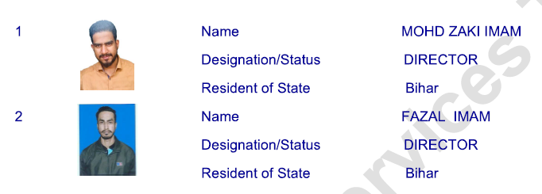

2.5 Factory of IMZAK Organics
The manufacturing and processing unit of IMZAK Organics is situated in Patna, Bihar, and serves as the operational hub for honey extraction, purification, and packaging. The factory is equipped with modern honey extraction machines, filtration units, and automated filling systems that ensure the retention of natural enzymes and nutrients in the honey.
The facility follows Good Manufacturing Practices (GMP) and Food Safety and Standards Authority of India (FSSAI) guidelines to maintain hygiene and safety at every stage of production. The factory employs skilled technicians who monitor the temperature, moisture level, and purity of honey during the production process.
Moreover, IMZAK Organics ensures zero-waste operations, where beeswax and other by-products are reused in producing natural skincare items. The company also has a research section that tests honey quality through sensory and chemical analysis. The entire setup reflects the company’s focus on technology, sustainability, and ethical business.

Infrastructure and Layout
The IMZAK Organics factory is well-structured, featuring designated sections for:
- Raw Honey Reception Area: Where freshly collected honey from partner beekeepers is received, weighed, and inspected for quality.
- Extraction & Filtration Unit: Equipped with centrifugal extractors, double-layer filtration systems, and moisture control units that ensure honey remains raw and nutrient-rich.
- Quality Testing Laboratory: A dedicated lab equipped with instruments to test moisture content, density, pH level, and purity of honey samples. Each batch undergoes chemical-free verification before packaging.
- Processing and Bottling Section: Automated filling and sealing machines handle different packaging sizes — from 125g jars to 5kg jerry cans.
- Storage & Dispatch Unit: The final products are stored in temperature-controlled warehouses to maintain freshness and consistency before being distributed to retail partners or shipped online.

2.6 Products of IMZAK Organics

  - Flavoured Honey

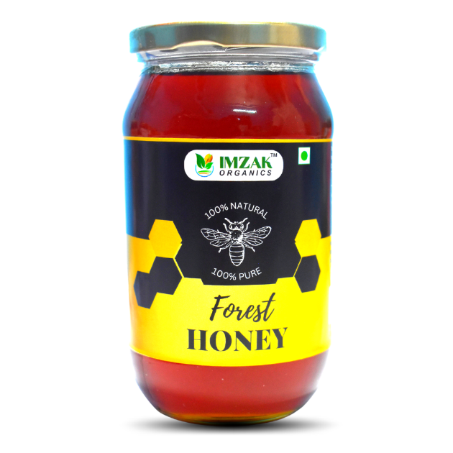 | 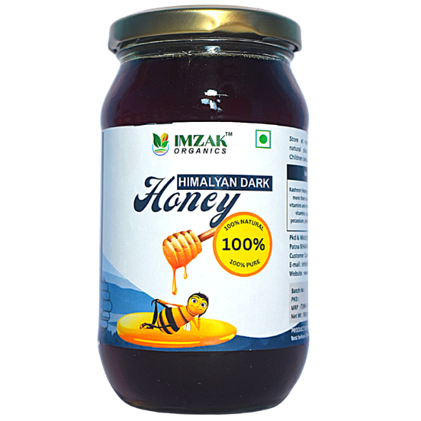
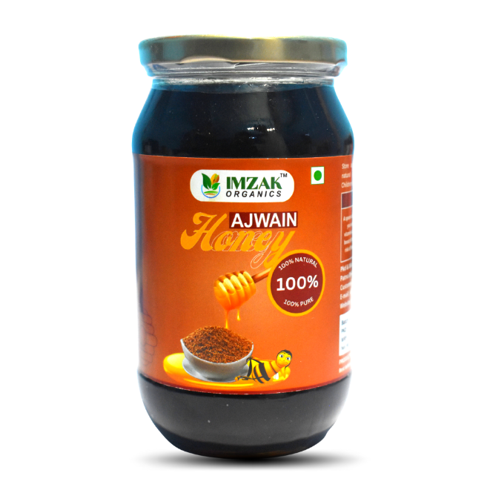 | 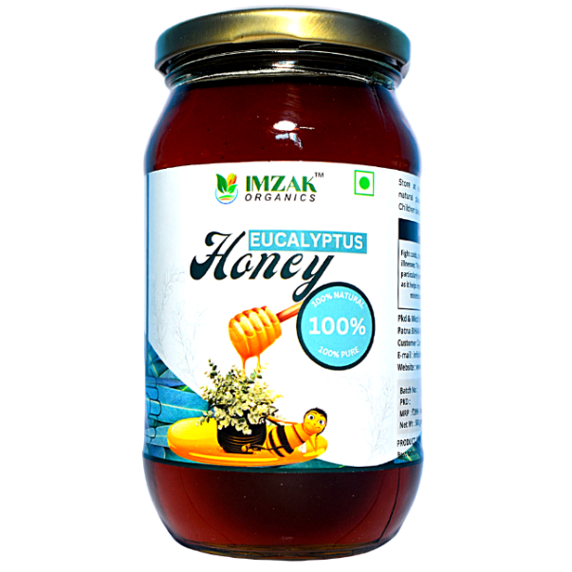

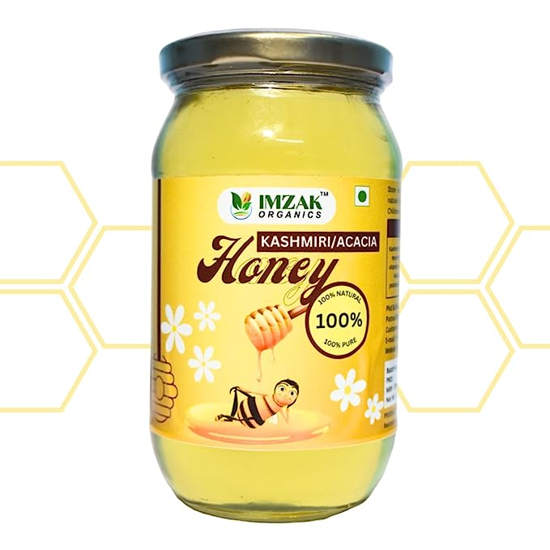 | 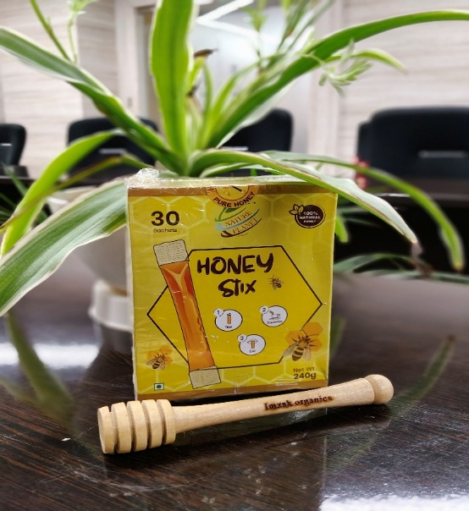
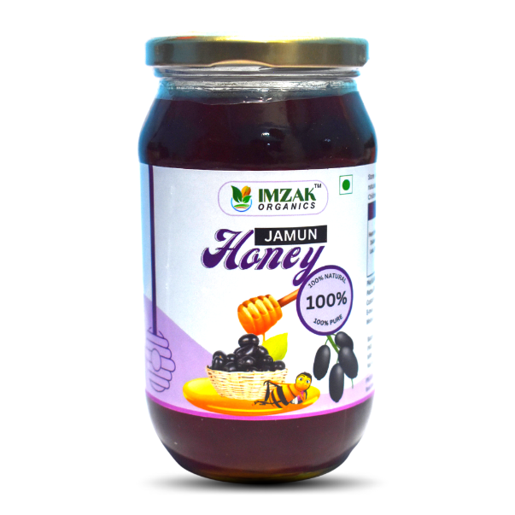 | 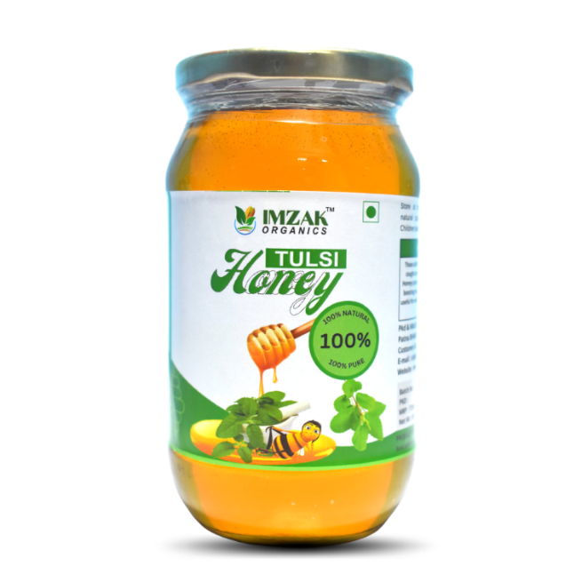

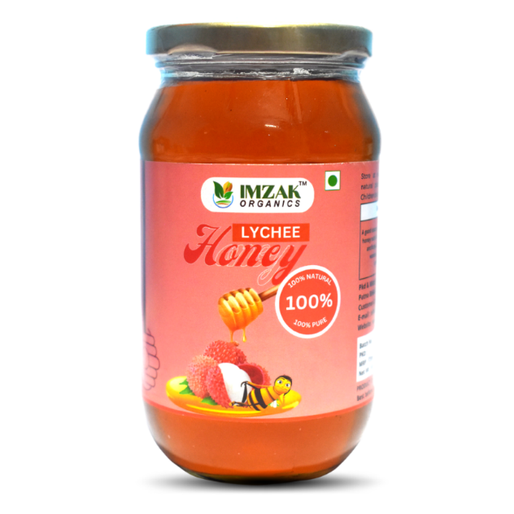 | 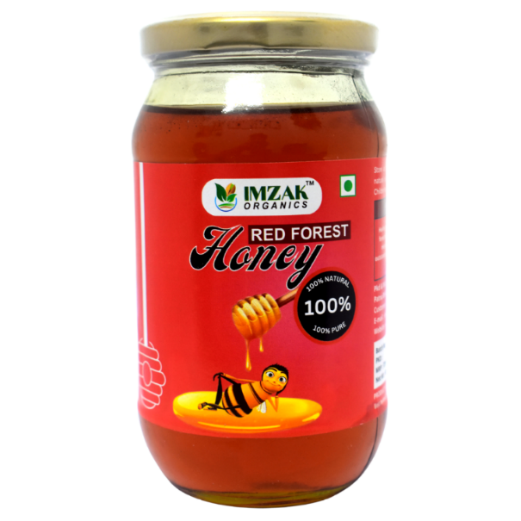
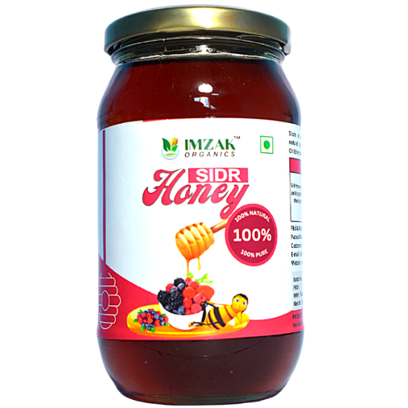 | 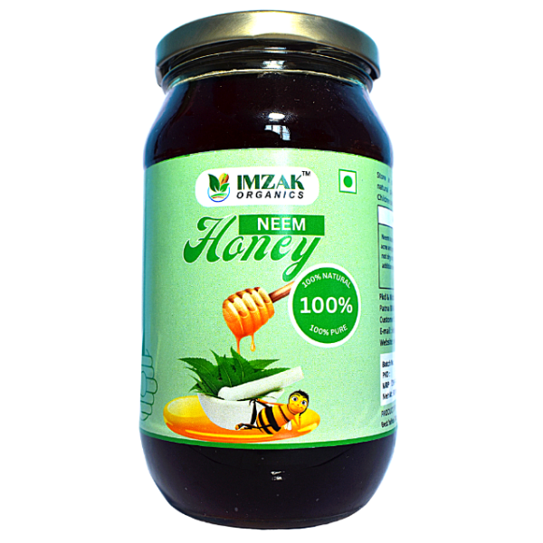

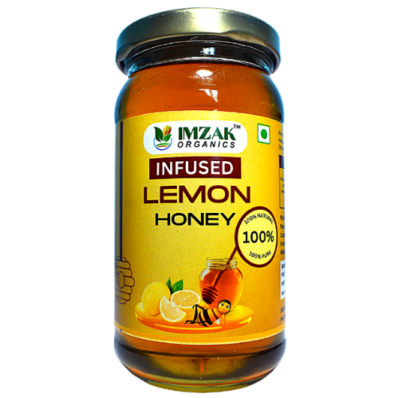 | 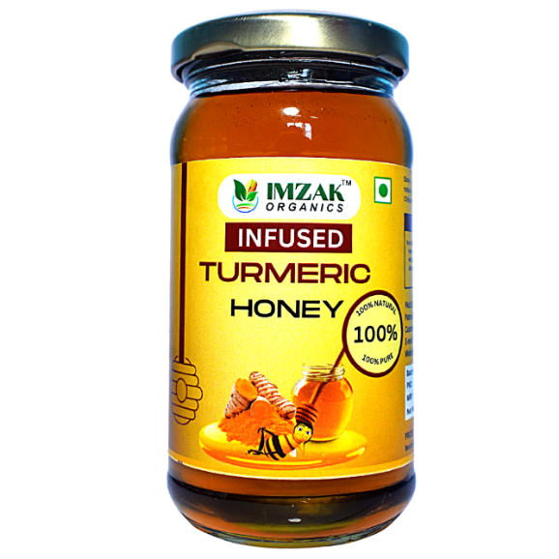
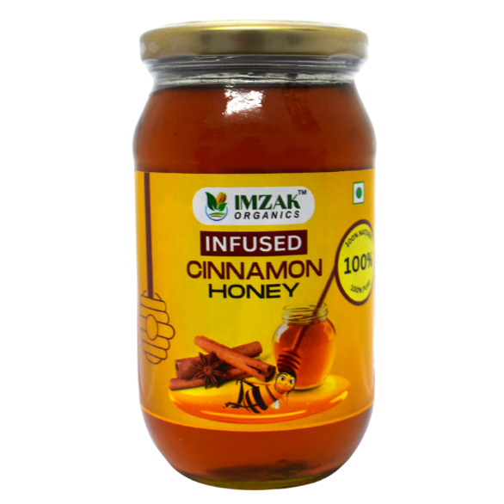 | 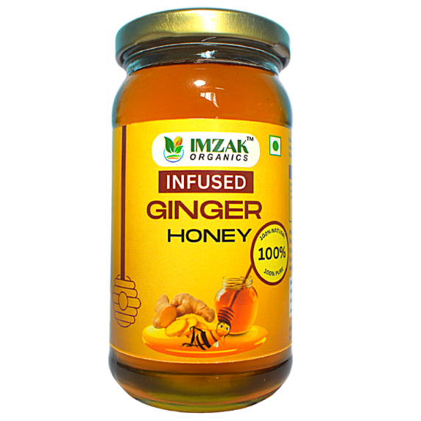

  - Infused Honey

  - Super Food
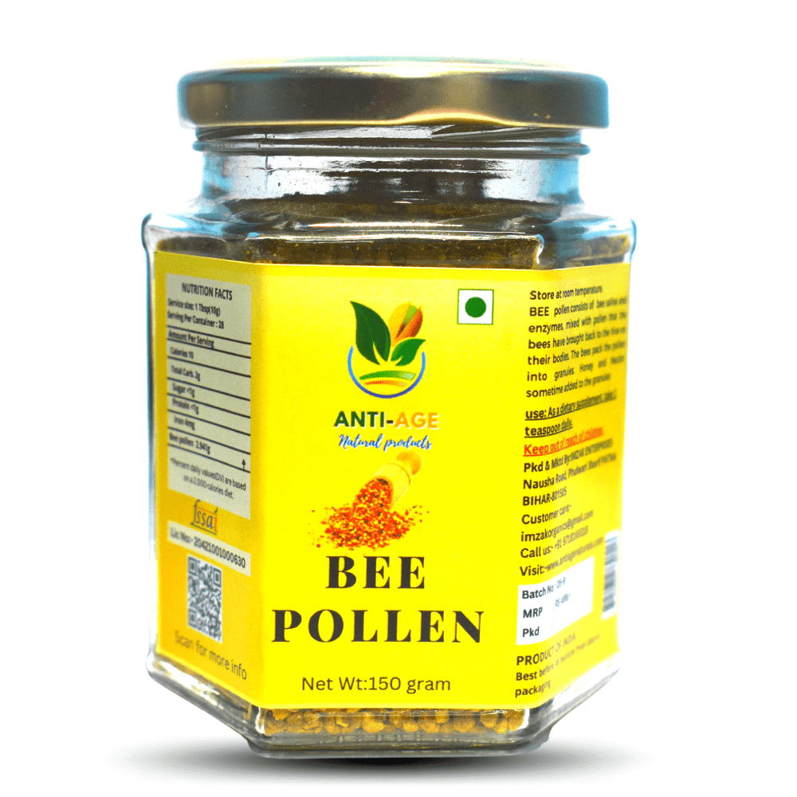 | 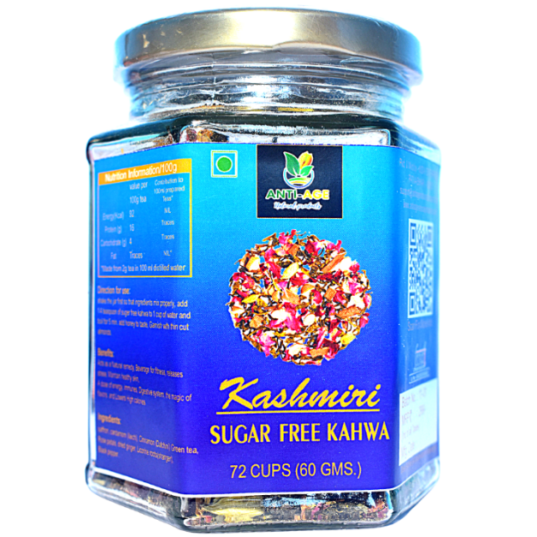
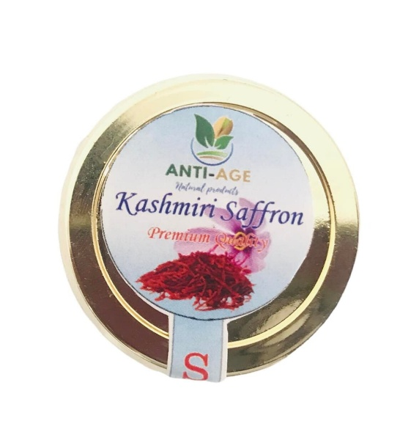 | 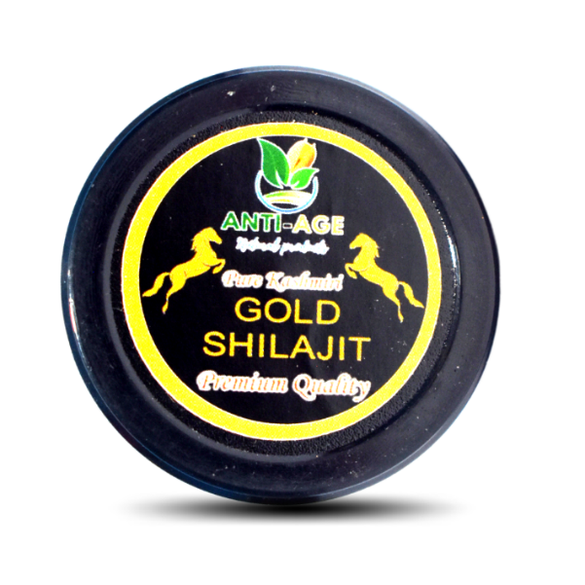

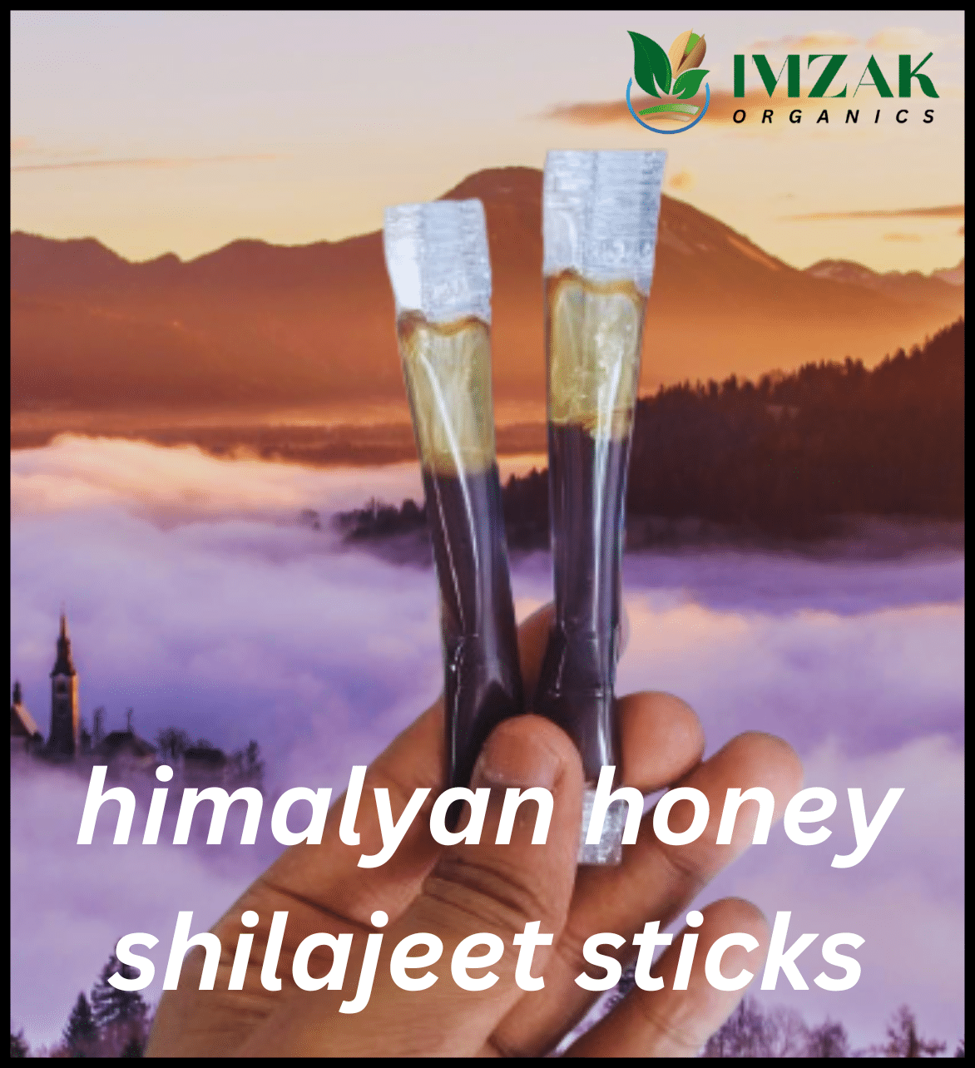 | 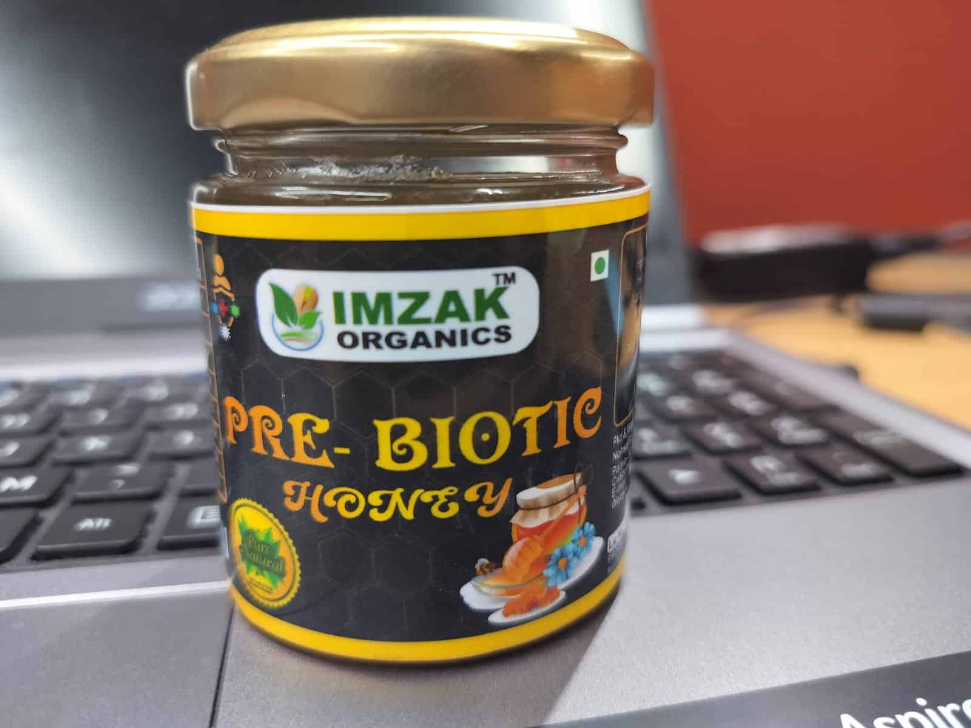
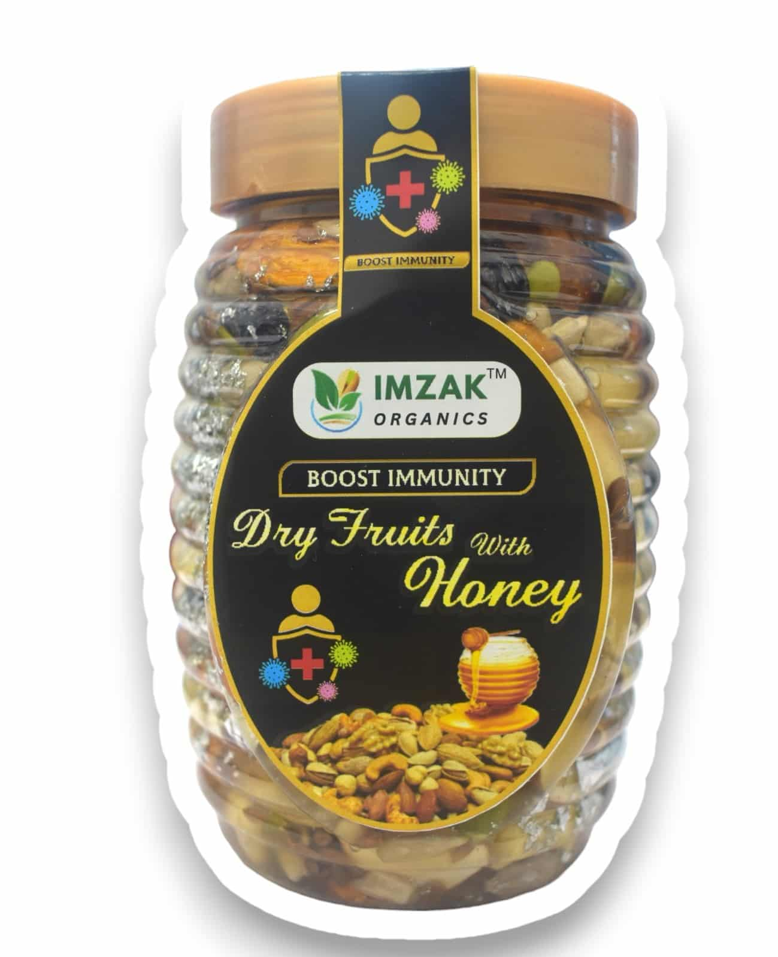 | 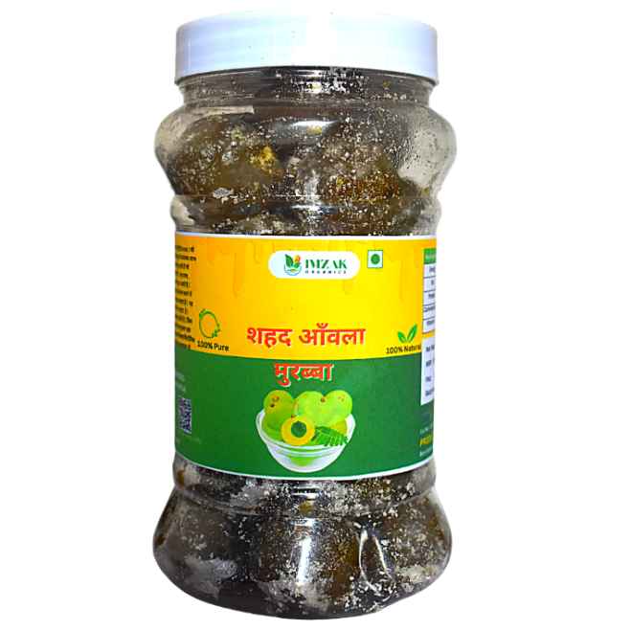

2.7 Steps Involved in Producing a Unit of Honey

The production process of honey at IMZAK Organics involves multiple stages that blend traditional methods with modern techniques to ensure quality and sustainability.

- Step 1: Beekeeping and Hive Management
Local beekeepers maintain bee colonies in wooden hives located in pollution-free rural areas rich in flowering plants. Bees collect nectar from flowers and convert it into honey naturally.
- Step 2: Collection of Honeycombs
Once the honeycombs are filled and sealed by the bees, beekeepers carefully collect them from the hives without harming the bees.
- Step 3: Extraction Process
The honey is extracted using centrifugal extractors that separate honey from the combs while maintaining its natural enzymes and antioxidants.
- Step 4: Filtration and Purification
The extracted honey is filtered to remove wax, pollen, and other impurities. IMZAK Organics uses multi-stage filtration systems to ensure clarity and purity.
- Step 5: Quality Testing
Samples are tested in the in-house laboratory for moisture content, pH level, and sugar composition to meet quality standards. Only the batches that pass all tests proceed to packaging.
- Step 6: Packaging and Labelling
Honey is filled into sterilized glass or PET containers using automated filling machines. Each jar is then sealed, labelled with nutritional information, and date-stamped.
- Step 7: Storage and Distribution
The final product is stored in temperature-controlled storage rooms to preserve freshness. From there, products are distributed to local retailers, wholesalers, and e-commerce partners across India.

This systematic process ensures that every unit of honey maintains the natural goodness, purity, and aroma that IMZAK Organics promises to its customers.

INTERNSHIP WORK AND MAJOR LEARNINGS

3.1 Internship Work

WEEK 1 (24th June – 27th June, 2025)
Day 1 – Tuesday, 24th June 2025:
The first day of my internship at IMZAK Organics marked the beginning of a professionally enriching journey in the FMCG and sustainable honey industry. The day commenced with a structured orientation session conducted by the management team. During this interaction, I was introduced to the company’s vision, mission, and strategic objective of promoting natural, organic, and eco-friendly honey-based products in the market. The organizational structure was explained in detail, allowing me to understand the interdependency between procurement, quality control, production, marketing, and sales units.
Following the orientation, I was taken on a facility tour where I observed the production and packaging setup. This visit helped me understand how raw honey is procured from local beekeepers, filtered, tested for moisture, and packaged with utmost hygiene and accuracy. I was briefed about moisture testing through a refractometer, primary filtration processes, label printing standards, and the sequential flow of the production cycle. This gave me a foundational understanding of the quality standards maintained in FMCG operations.
Post the facility walk-through, I was assigned my first operational task involving packaging and printing vendor coordination. I reviewed label specifications, colour themes, bottle dimensions, and adhesive properties to ensure product compatibility and regulatory compliance. I contacted multiple vendors to request quotations, samples, and delivery timelines. This activity provided me exposure to vendor negotiation, technical specification drafting, and understanding material quality decisions such as matte vs. gloss finish, barcode legibility, and print durability.
Toward the end of the day, I prepared a preliminary vendor comparison sheet and compiled key insights for the team. This exercise enhanced my ability to analyse commercial proposals, evaluate supplier reliability, and understand procurement decision-making.
Reflection:
My first day provided a holistic induction into the operational ecosystem of an FMCG startup. Observing real-time coordination between teams and understanding the emphasis on quality reinforced the importance of strong process management. I also realized that packaging plays a crucial role not only in product safety but also in influencing consumer perception and brand credibility. The experience motivated me to approach the upcoming days with curiosity, discipline, and eagerness to contribute meaningfully.

Day 2 – Wednesday, 25th June 2025:
The second day of my internship focused primarily on supporting the marketing department in executing a professional product photoshoot for IMZAK Organics’ honey range. The aim was to develop high-quality visual assets for digital marketing, e-commerce listings, brochures, and brand identity enhancement.
In the first half of the day, I assisted the marketing team in planning the photoshoot theme and selecting suitable backgrounds, lighting angles, and supporting props. We opted for natural, earthy backgrounds such as wooden boards and jute fabric to align with the brand’s organic positioning. I helped in product staging by ensuring bottles were clean, labels were aligned perfectly, and caps had no fingerprints or smudges. These detailing activities helped me understand how aesthetics influence consumer perception and how product photography directly impacts brand trust and visibility.
During the shoot, I observed techniques for natural light management, controlled reflections on glass jars, maintaining consistent white balance, and capturing macro shots for label clarity. In addition, I helped manage product movement, arranged backup units, and coordinated with the team on shot composition matrices.
In the latter half, I assisted in organizing the captured images, reviewing sample shots for clarity, colour accuracy, and presentation quality. I suggested minor adjustments in background placement and product angles, which were appreciated by the team. I also learned about safe handling of inventory during visual production activities and the importance of FIFO (First-In-First-Out) to prevent product aging on shelves.
Reflection:
Day two significantly strengthened my understanding of brand communication through visuals. I realized that even premium product quality requires strong visual representation to influence buyer decisions. The experience emphasized patience, precision, and creativity, highlighting how minor details such as label alignment and lighting direction can drastically affect brand perception. I also gained confidence in my ability to contribute meaningfully to creative marketing activities.

Day 3 – Thursday, 26th June 2025:
On the third day of my internship, I gained practical exposure to market research and direct consumer interaction. The day involved visiting Khadi Mall, Patna, to observe the retail environment and study the honey and organic product segment. The primary objective was to understand competitor offerings, packaging strategies, pricing structures, and consumer buying behaviour.
I began by exploring various brands positioned in the organic and premium honey space. I analysed packaging styles, label designs, claimed nutritional benefits, certifications, and SKU variations. Notably, premium brands used amber glass bottles, matte-textured labels, and minimalistic designs to convey purity and credibility. I recorded price comparisons across variants like multifloral, wild honey, and infused honey ranges. These observations helped me understand market segmentation, value proposition structuring, and how packaging aesthetics influence willingness to pay.
Post analysis, I assisted in setting up a product sampling counter for IMZAK Organics. Throughout the day, I engaged with customers, offered product tasting, and delivered a concise product introduction highlighting sourcing transparency, purity, and nutritional value. I addressed pricing-related questions by explaining the procurement quality, filtration practices, and brand ethos towards sustainability and health.
This real-time engagement enhanced my communication and persuasion skills. I noticed that customers showed high interest after tasting the product, reaffirming that sensory experience plays a vital role in FMCG sales. By the end of the day, I contributed to the sale of approximately ₹14,000, a rewarding achievement that reinforced confidence in my selling capabilities and understanding of consumer psychology.
Reflection:
Day three exposed me to practical retail dynamics and customer interaction psychology. I learned that successful FMCG selling requires a combination of product knowledge, confidence, and consumer engagement techniques. The experience strengthened my interpersonal communication skills and helped me appreciate the importance of in-person brand promotion in building consumer trust and sales momentum.

Day 4 – Friday, 27th June 2025:
Day four of my internship focused on supplier sourcing and documentation for packaging materials and herbal additives. I was assigned the task of identifying potential vendors for bottles, caps, labels, and infused product ingredients aligned with IMZAK Organics’ expansion needs.
I researched credible suppliers online and through existing trade networks, comparing minimum order quantities, logistical terms, sample availability, and material composition details. I requested catalogues, technical specifications, and quality certifications from shortlisted suppliers. Compiling this data into a structured vendor comparison sheet allowed me to evaluate options on parameters like cost efficiency, delivery timelines, quality assurance, and flexibility for small-batch procurement.
Simultaneously, I worked on building a product catalogue draft for the company. I organised product photos, added key information including sourcing notes, nutritional details, and usage recommendations, and ensured formatting consistency. The task required accuracy, attention to detail, and understanding of brand positioning.
This exercise provided hands-on exposure to procurement planning and marketing collateral creation. I also coordinated with supervisors to finalise shortlisted suppliers and align catalogue content with the brand narrative.
Reflection:
The day enhanced my analytical and documentation skills. I learned how vendor reliability, cost structures, and material quality collectively influence procurement decisions in FMCG. The catalogue work taught me the importance of product presentation in strengthening customer perception and supporting sales activities. Overall, the experience fostered a deeper appreciation for backend operations critical to successful product management.
WEEK 2 (30th June – 5th July, 2025)
Day 1 – Monday, 30th June 2025:
The second week of my internship began with an engaging and technically rich learning experience on the production floor. The focus of the day was to gain deeper insight into the filtration and moisture control stages of honey processing. I observed the team handling raw honey that had just been collected from primary storage drums. The production supervisor demonstrated how unprocessed honey typically contains microscopic wax particles, bee pollen residues, and other natural matter that needs to be filtered while still retaining its intrinsic nutrients, flavour profile, and natural golden colour. It was fascinating to see how filtration plays a delicate role—too coarse a filter, and impurities may pass through; too fine, and one risks removing naturally beneficial components that contribute to the honey’s identity.
A major point emphasised throughout the day was temperature control. Honey, being a biologically active natural product, is extremely sensitive to heat exposure. I learned that controlled warming between a specified temperature range increases honey’s fluidity, making it easier to filter and pack into jars. However, crossing the optimal temperature threshold can degrade delicate enzymes and natural antioxidants present in honey. Moreover, excessive heating increases the risk of elevated Hydroxymethylfurfural (HMF) levels, a compound that forms when sugar undergoes heat breakdown and is considered a key quality indicator in the honey industry. Maintaining HMF within acceptable limits is essential for regulatory compliance and market trust.
I also practiced using a refractometer, an industry-standard tool to measure moisture content and soluble solid concentration. Through hands-on guidance, I learned how the moisture content of honey is directly linked to its shelf life and fermentation risk. A higher-than-recommended moisture percentage can lead to fermentation during storage, which affects flavour, aroma, and consumer acceptability. The refractometer readings allowed the quality team to ensure that the batch met standards before moving to the filling process.
Another important takeaway was the importance of workflow discipline. I learned how even slight delays in transferring honey from filtration to filling can change viscosity due to temperature drops, affecting filling accuracy and causing inconsistencies in jar weights. This could result not only in consumer dissatisfaction but also in regulatory packing compliance issues. Consistency and standardisation, I realised, form the backbone of the food manufacturing sector.
By the end of the day, I gained a deeper appreciation of the scientific precision behind what seems like a simple natural product. Honey processing is not merely about extraction and packaging—it involves controlled conditions, real-time monitoring, and technical knowledge. This session made me recognise the importance of quality-driven production and the impact of seemingly small operational choices on the final consumer experience. The day strengthened my understanding of the interconnectedness of temperature, moisture, filtration, and workflow efficiency in maintaining premium product quality.

Day 2 – Tuesday, 1st July 2025:
On the second day of the week, I shifted gears from production to administrative and market research responsibilities. My assignment revolved around designing a comprehensive Google Form for vendor registration and market inquiry, a task that tested both my analytical thinking and my understanding of procurement needs in an FMCG environment. The objective was to create a structured, professional, and user-friendly tool that could help streamline supplier onboarding and initial evaluation processes.
I began by listing all critical vendor information that would support procurement and quality assessment. This ranged from general business details, product categories, certifications (such as FSSAI, ISO, and organic labels), yearly production capacity, and logistics capabilities, to financial policies such as pricing, minimum order quantities (MOQs), payment terms, lead times, and sampling procedures. The form had to be detailed yet simple, ensuring suppliers could complete it efficiently while providing robust data for evaluation. I used logical sectioning, drop-down lists, and mandatory fields to maintain uniformity and ease of comparison later.
In parallel, I drafted formal outreach emails that would be circulated to shortlisted vendors. I ensured the tone was professional and concise, attaching a specification sheet that detailed our requirements for jars, caps, and additives such as natural flavours or herbal extracts. The email also clearly mentioned submission deadlines for quotes and sample dispatches, maintaining a well-defined communication structure. The intention was to reduce ambiguity and promote faster, more organised responses.
One valuable learning was the importance of precision in documentation—poorly drafted requests often lead to unclear proposals and delays. Another takeaway was understanding how digital data collection tools accelerate procurement efficiency. A streamlined acquisition of supplier information not only reduces administrative load but also helps teams make informed decisions faster. This activity exposed me to the importance of operational discipline, professionalism in corporate communication, and how well-designed digital systems strengthen internal workflows.
By the end of the day, I had conducted multiple test submissions, reviewed field logic, and refined the document to ensure usability. The procurement manager appreciated the clarity and flow of the form. This task enhanced my understanding of supply chain documentation, vendor discovery, and the strategic role of structured information gathering in business operations. It was a rewarding experience as it blended technology, business logic, and real-world procurement application.

Day 3 – Wednesday, 2nd July 2025:
Wednesday’s focus was vendor evaluation and negotiation — a crucial step before procurement decisions are finalised. The day was a practical lesson in real-world supplier screening and commercial communication. My role was to analyse responses received through the vendor form, assess quotations, and evaluate readiness for sample provision and delivery. I realised early that vendor evaluation extends far beyond comparing price tags; it involves assessing reliability, professionalism, and long-term suitability.
I categorised vendors based on pricing, production capacity, packaging quality, and responsiveness. I reviewed how effectively they addressed our provided specifications — for example, whether they offered food-grade certified caps, whether they understood our volume requirements, and whether they could accommodate urgent orders. Packaging integrity was another important criterion, especially for glass jars, since improper packaging increases damage risk during transit. I also checked the availability of trial pricing or small-batch rates — a frequent necessity for emerging brands that scale gradually.
A highlight of the day was participating in negotiation discussions. I practiced articulating price expectations, explaining budget rationales, and politely requesting improved quotations for long-term partnerships. I also discussed payment timelines, logistics support, and whether the vendor offered after-sales service or replacement assurance for damaged items. I observed that negotiation is not about pressuring vendors but building mutually beneficial relationships grounded in fairness and clarity.
I consolidated my findings into a structured comparison sheet that included qualitative and quantitative parameters. This document helped the team visualise where each vendor stood in terms of value, service reliability, and business synergy. By evening, we had shortlisted multiple suppliers and initiated trial orders.
Overall, the day enhanced my understanding of procurement strategy, negotiation etiquette, and evaluation frameworks. It demonstrated that good procurement is a blend of financial prudence, relationship management, and meticulous review — skills essential for anyone aspiring to managerial roles in FMCG or business development.

Day 4 – Thursday, 3rd July 2025:
Thursday was dedicated to order initiation and exploring diversification opportunities. After finalising vendors, I assisted in preparing purchase orders (POs) for key packaging materials including jars, caps, liners, and sealing accessories. I ensured that specifications such as jar dimensions, cap threading, inner liner fit, sealing performance expectations, and delivery acceptance criteria were clearly mentioned. I also checked that delivery timelines, payment structure, and quality parameters were well stated to prevent misunderstandings after dispatch.
Beyond packaging procurement, my supervisor assigned a research task regarding potential expansion into Gulkand — a rose petal preserve product often paired with honey in wellness and artisanal gifting categories. This was particularly exciting because it exposed me to category expansion thinking and product portfolio diversification strategies. I studied multiple suppliers online, reviewing ingredient sourcing methods, sugar concentration standards, and whether the products had natural rose petals or artificial syrups. I analysed shelf-stability claims, storage requirements, and compatibility with honey gift hampers in terms of aesthetics and production synergy.
This exercise expanded my perspective on brand strategy. I learned how companies cautiously explore adjacent product lines, test feasibility, and evaluate whether consumer demand aligns with operational capacity. The research taught me that diversification must not compromise brand identity — in this case, natural wellness and purity remained key themes.
The day strengthened my understanding of structured procurement execution and forward planning for new category trials. I concluded the day with notes summarising supplier options, product characteristics, and cost implications, ready for further team review.

Day 5 – Saturday, 5th July 2025:
Saturday brought me back to the production unit, reinforcing the operational insights I gained earlier in the week. I assisted the team on the packaging line and observed how technological calibration and manual checks work together to maintain product consistency. The day began with machine setup, where the filling system was adjusted to dispense honey uniformly into jars. I learned how viscosity plays a major role — even small variations due to temperature can influence filling accuracy, making real-time parameter checks necessary.
I monitored capping procedures and gained insight into ensuring optimum torque levels. A cap that is too loose risks leakage, moisture exposure, and product spoilage; a cap that is overtightened may crack or damage threading and compromise sealing integrity. I also checked label alignment, ensuring consistency and market-ready presentation. Batch coding procedures were explained to me, a crucial process for traceability and regulatory compliance.
A significant part of the day revolved around routine quality checks. I once again used the refractometer to confirm uniform moisture content across the production cycle. Periodic checks help detect deviations quickly, preventing entire batches from falling below standard. I also observed how the team documented inspection results and corrective actions, ensuring transparency and traceability — something consumers today value highly.
The experience emphasised how meticulous standard operating procedures (SOPs), skilled personnel, and effective teamwork collectively ensure product excellence. Quality assurance isn’t a one-time task; it is a continuous discipline. I realised how coordinated production contributes to brand credibility, reduced wastage, cost efficiency, and ultimately consumer satisfaction.
By the end of the day, I felt more confident in understanding FMCG quality systems and production dynamics. The hands-on learning strengthened my appreciation of precision, routine monitoring, and workplace discipline in manufacturing environments. It was a valuable and fulfilling conclusion to the week.

WEEK 3 (8th July – 12th July, 2025)
Day 1 – Tuesday, 8th July 2025:
The week began with a field visit to Upendra Maharati Shilp Anusandhan Sansthan, a government-supported institute renowned for preserving traditional Indian handicrafts and sustainable materials. The objective of this visit was to evaluate eco-friendly packaging alternatives that could align with IMZAK Organics’ mission of promoting natural wellness and ethical consumerism. Since honey and wellness products are typically associated with purity and nature, packaging plays an essential role in shaping consumer perception and reinforcing brand values.
During the visit, I explored different packaging formats such as kraft paper sleeves, jute fabric wraps, handcrafted paper boxes, bamboo lids, and wooden gift cases. Each option brought a unique aesthetic and tactile experience, giving a premium, artisanal feel that could appeal to eco-conscious urban consumers and elevate IMZAK’s gifting range. Beyond design appeal, my assessment was guided by practical production and logistics criteria. For example, I learned about the importance of durability during transport, moisture resistance—critical in monsoon conditions—and print compatibility, especially where branding details must remain sharp and legible.
I engaged in discussions regarding unit cost structures, lead times, storage requirements, and environmental impact across the product lifecycle. One insight was that sustainability often introduces trade-offs; for instance, jute wraps offer biodegradability and visual appeal, but they require dry storage conditions and higher unit costs versus standard packaging. Wooden boxes add significant customer value but increase weight, shipping cost, and handling complexity. Kraft sleeves are versatile and affordable but may need lamination to protect print quality, raising questions about recyclability. This exercise helped me recognise the fine balance between environmentally responsible choices and operational feasibility in a competitive FMCG market.
Parallel to the visit, I reviewed IMZAK’s raw material consumption patterns, focusing on jars, caps, shrink sleeves, and labels. Using procurement logs and production forecasts, I reconciled stock-in and stock-out records and placed replenishment orders aligned with batch-wise production cycles. This ensured that inventory levels remained healthy without blocking excess capital or risking spoilage and design obsolescence. I also learned how procurement timelines must anticipate supplier delays, logistics disruptions, and seasonal demand fluctuations to avoid bottlenecks.
By the end of the day, I had developed a more holistic view of supply-chain planning and product presentation. The visit broadened my understanding of sustainable packaging, not as a trend but as a strategic brand element requiring thoughtful execution and cost-benefit evaluation. Equally, the inventory planning task demonstrated how data-driven decision-making safeguards operational flow and supports marketing commitments with reliable supply availability. This day reinforced that responsible growth requires integrating creativity, sustainability, and discipline—hallmarks of a brand aspiring to stand out in the natural-foods sector.

Day 2 – Wednesday, 9th July 2025:
The second day of the week was divided between sales engagement and supplier evaluation, offering valuable exposure to the interdependence between demand generation and supply assurance. With weekly sales targets established by the business team, my morning was spent reaching out to potential retailers, distributors, and boutique wellness stores who had previously expressed interest in stocking IMZAK products. I shared an updated digital catalogue featuring product photographs, ingredient highlights, and pricing tiers, along with curated lifestyle visuals designed to communicate the ethos of purity, authenticity, and handcrafted quality.
During these outreach calls and follow-ups, I learned how effective communication plays a vital role in building trust and converting leads. Retailers often sought clarification on areas like minimum order quantities, shelf-life assurance, return policies, and delivery timelines. I noticed that timely response, clarity in information, and consistency in tone are key determinants of how seriously a young brand is perceived in the marketplace. Additionally, I prepared messaging templates to ensure uniformity across conversations and improve efficiency in responding to inquiries.
In parallel, I analysed incoming submissions from the vendor registration form developed earlier. I categorised suppliers on the basis of product category (jars, edible additives, packaging elements), geographic location, capacity, pricing tiers, and responsiveness. One important learning was that supplier reliability is not always correlated with lowest price. Instead, I evaluated parameters such as documentation quality, sample policy, transparency in communication, and willingness to accommodate trial production. I also examined reference photos shared by suppliers to assess product finish and packaging integrity, particularly in the case of glassware suppliers where breakage risk is high.
As I reviewed vendor profiles, I observed that procurement discipline underpins sales credibility. Without dependable vendors and verified supply schedules, commitments made to customers may be difficult to fulfil, risking erosion of trust and brand value. Conversely, strong supplier partnerships support competitive pricing, product consistency, and the ability to scale confidently. This day taught me how sales and procurement operate symbiotically—an efficient supply chain enhances customer confidence, and confirmed orders strengthen negotiation leverage with vendors.
Toward the end of the day, I documented retailer responses and vendor evaluations in separate trackers for management review. These updates helped the team make informed decisions on lead prioritisation and supplier follow-up. The experience expanded my understanding of cross-functional coordination, pipeline management, and stakeholder communication in a D2C and distribution-focused business environment. Overall, the day reinforced the importance of structured outreach, follow-through, and data-based supplier benchmarking as foundational pillars for scaling a consumer brand sustainably.

Day 3 – Thursday, 10th July 2025:
Thursday was dedicated to production and packaging support in the manufacturing unit, offering another grounded lesson in quality control, compliance, and operational hygiene. My responsibilities revolved around assisting with labelling and verification tasks to ensure regulatory accuracy and brand consistency. At first glance, applying labels may seem like a routine job, but I soon realised how much discipline and precision it requires in a regulated food-processing environment.
I learned to align labels at a consistent height on each jar, ensuring clean adherence without air bubbles. Uneven placement or trapped bubbles not only affect visual appeal but may also cause peeling during transportation, diminishing product value and consumer impression. I paid particular attention to ensuring that every jar carried mandatory consumer-facing information including net contents, ingredient list, batch number, manufacturing and best-before timelines, FSSAI license, vegetarian symbol, and storage conditions. Through this task, I gained an appreciation of how packaging serves as both a branding medium and a legal compliance tool.
I also observed the sanitisation protocols followed by the production staff. Surfaces were wiped at defined intervals using food-grade disinfectants, protective gear such as gloves, hairnets, and aprons were worn as per SOP, and finished product areas were strictly segregated from raw material handling sections. The hygiene procedures reminded me that India's food safety ecosystem, under FSSAI, emphasises traceability and consumer protection—compliance here is not optional; it is fundamental to business continuity and ethical practice.
Throughout the day, the production supervisor reinforced the importance of batch quality checks and documentation. I assisted in inspecting jars post-labeling, segregating any with visible defects, and confirming coding accuracy. The team also recorded checks in quality logs, highlighting how documentation establishes accountability and facilitates audits.
What stood out most was the understanding that compliance goes beyond meeting regulatory requirements—it reflects respect for consumers and commitment to product integrity. A lapse in quality or labelling accuracy can result in financial penalties, product recalls, and loss of market trust. Conversely, consistent adherence builds brand credibility and consumer loyalty. This day deepened my appreciation of operational rigour and instilled a mindset of quality consciousness, which is essential in consumer-oriented sectors like FMCG and wellness.
Thursday was dedicated to production and packaging support in the manufacturing unit, offering another grounded lesson in quality control, compliance, and operational hygiene. My responsibilities revolved around assisting with labelling and verification tasks to ensure regulatory accuracy and brand consistency. At first glance, applying labels may seem like a routine job, but I soon realised how much discipline and precision it requires in a regulated food-processing environment.
I learned to align labels at a consistent height on each jar, ensuring clean adherence without air bubbles. Uneven placement or trapped bubbles not only affect visual appeal but may also cause peeling during transportation, diminishing product value and consumer impression. I paid particular attention to ensuring that every jar carried mandatory consumer-facing information including net contents, ingredient list, batch number, manufacturing and best-before timelines, FSSAI license, vegetarian symbol, and storage conditions. Through this task, I gained an appreciation of how packaging serves as both a branding medium and a legal compliance tool.
I also observed the sanitisation protocols followed by the production staff. Surfaces were wiped at defined intervals using food-grade disinfectants, protective gear such as gloves, hairnets, and aprons were worn as per SOP, and finished product areas were strictly segregated from raw material handling sections. The hygiene procedures reminded me that India's food safety ecosystem, under FSSAI, emphasises traceability and consumer protection—compliance here is not optional; it is fundamental to business continuity and ethical practice.
Throughout the day, the production supervisor reinforced the importance of batch quality checks and documentation. I assisted in inspecting jars post-labeling, segregating any with visible defects, and confirming coding accuracy. The team also recorded checks in quality logs, highlighting how documentation establishes accountability and facilitates audits.
What stood out most was the understanding that compliance goes beyond meeting regulatory requirements—it reflects respect for consumers and commitment to product integrity. A lapse in quality or labelling accuracy can result in financial penalties, product recalls, and loss of market trust. Conversely, consistent adherence builds brand credibility and consumer loyalty. This day deepened my appreciation of operational rigour and instilled a mindset of quality consciousness, which is essential in consumer-oriented sectors like FMCG and wellness.

Day 4 – Saturday, 12th July 2025:
The final day of the week focused on brand communication and digital marketing, highlighting how creativity and strategic clarity shape consumer engagement. With rising competition in the natural foods space, content plays an essential role in building awareness and establishing brand authenticity. My task for the day was to participate in the development of social-media-friendly content—specifically short-form videos and product photography emphasising purity, everyday usability, and origin-based storytelling.
I collaborated with the marketing team to plan shots, select setups, and script short captions. We utilised natural lighting and minimal-props styling to maintain an organic, home-grown aesthetic. The idea was to show honey not only as a product but as a lifestyle accompaniment—drizzling over toast, being mixed into warm water or herbal tea, or paired with homemade snacks. The focus was not on aggressive selling but on evoking trust and familiarity.
During content review, I learned that first few seconds are crucial to retain viewer attention. We ensured that opening frames were visually striking and aligned with brand colour tones. Captions were short, authentic, and benefit-oriented, avoiding exaggerated claims. I also learned to add subtle but effective call-to-action prompts such as “follow for more wellness tips” or “link in bio for product info,” which help convert casual viewers into followers and potential buyers.
Another learning was the importance of consistency across fonts, background palette, language tone, and messaging themes. A brand grows stronger not by saying many different things at once but by reinforcing a small set of core promises repeatedly—such as purity, traceability, and natural goodness. We also discussed frequency planning and how maintaining a predictable content schedule helps build recall among audiences.
By the end of the session, I better understood how digital perception shapes consumer behaviour, particularly for D2C wellness brands that depend heavily on online engagement. The exercise taught me that effective content is not merely aesthetic—it is strategic, value-oriented, and disciplined. It blends creativity with business intent and plays a crucial role in brand building and lead generation.

WEEK 4 (14th July – 19th July, 2025)
Day 1 – Monday, 14th July 2025:
The week began with another round of field visits to explore exhibition and retail collaboration opportunities that could help IMZAK Organics expand its brand presence and reach new consumer groups. I revisited Upendra Maharati Shilp, Khadi Mall, Vikas Bhawan, and Bihar Vidyapeeth, each known for hosting cultural, artisanal, and organic-product exhibitions throughout the year. The objective was to evaluate their suitability as venues for product stalls and brand showcases.
At each site, I collected detailed information about venue infrastructure, stall charges, visitor profiles, logistical facilities, and seasonal footfall variation. The first venue, Upendra Maharati Shilp, attracts an audience that values traditional craftsmanship and handmade products, aligning well with IMZAK’s natural positioning. However, its footfall fluctuates based on festival seasons. Khadi Mall offered a strong synergy with wellness and sustainability-driven consumers, and the presence of government-supported handicraft sellers created an ecosystem favourable for natural product brands.
Vikas Bhawan and Bihar Vidyapeeth had diverse crowds — from students and young professionals to families — giving access to an audience that is price-sensitive yet increasingly health-conscious. Collecting data on stall rental rates, electricity access, placement priority, availability of display racks, and storage facilities helped me compare venues not only on brand fit but also cost-efficiency and operational practicality. I also assessed accessibility and parking facilities as these factors influence footfall and how easily customers can browse and purchase without inconvenience.
During interactions with coordinators, I specifically enquired about upcoming exhibition schedules and whether IMZAK Organics could participate during peak visitor seasons, such as festivals and public events. I learned that timing and event themes significantly affect sales potential — organic and wellness-themed fairs offer more relevant engagement than general trade exhibitions.
After returning to the office, I compiled all gathered information into structured notes and created a prioritization matrix based on target audience alignment, cost-benefit analysis, timing opportunities, and brand visibility potential. I also included notes on inventory freshness considerations — since honey is a natural consumable product, sale cycles need to align with production freshness and packaging timelines. Seasonal footfall patterns, especially during winter and festive periods, were flagged as high-opportunity windows.
This exercise reinforced the importance of strategic offline marketing, especially for emerging natural brands that require direct consumer interaction to build trust. It deepened my understanding of customer segmentation and analytical evaluation and highlighted how brand exposure investments must balance financial prudence with long-term brand building. The day strengthened my ability to evaluate experiential marketing opportunities and plan ahead for resource allocation and operational execution.

Day 2 – Tuesday, 15th July 2025:
Tuesday was a production-focused day where my primary responsibility was supervising key parts of the honey bottling and labelling process while reinforcing IMZAK Organics’ quality standards. Before production began, I conducted a quick 5S-style workstation inspection — ensuring tools were organized, labelling rolls were stocked, cleaning cloths were available, and workspace surfaces were sanitised and clutter-free. This approach promotes workflow efficiency, reduces contamination risk, and improves worker productivity.
As production progressed, we spotted a slight inconsistency in label alignment across a subset of bottles. Instead of allowing the issue to continue, which could lead to significant rework later, I paused the line briefly. Working alongside the production team, I inspected the labelling jig and identified that the alignment arm needed minor adjustment. After correcting the jig and testing several trial bottles, production resumed smoothly.
This incident was a practical lesson in early defect intervention. Addressing issues in real time prevents compounding errors and protects brand presentation. Label alignment may seem minor, but packaging aesthetics influence consumer perception, shelf appeal, and retail acceptance — especially in premium natural and artisanal products.
The remaining hours involved monitoring consistency in bottle filling, seal integrity, hygiene compliance, and batch documentation. I also ensured that all QC-approved batches were properly segregated and coded before moving to storage. Observing this process again reaffirmed how operational discipline directly translates into product consistency and consumer trust.
A major takeaway from the day was the importance of proactive supervision, quick corrective action, and continuous improvement mindset. Even a small misalignment, if ignored, can reduce efficiency, delay shipment timelines, and increase cost per unit due to rework. This experience strengthened my understanding of quality culture, lean manufacturing concepts, and leadership responsibility during production cycles.

Day 3 – Wednesday, 16th July 2025:
Wednesday focused on digital marketing and content creation — specifically editing pre-recorded footage to produce cohesive advertising assets for social media platforms. My task required balancing creativity with brand discipline while ensuring content delivered clarity and authenticity.
I began by categorizing raw footage into themes like product usage, purity, sourcing narrative, and lifestyle positioning. I then structured short videos that followed a simple yet effective narrative arc: attention-grabbing opening, informative middle, and clear closing message. Attention to pacing, scene transitions, and music helped create smooth flow and emotional connection.
Colour correction was an important component — enhancing warm amber tones of honey while maintaining natural texture and avoiding artificial enhancement. I also adjusted audio levels to ensure voiceover clarity and balanced background instrumental elements. Branding rules were carefully applied: consistent placement and treatment of the logo, uniform fonts for captions, and adherence to IMZAK’s beige-gold-white theme palette.
I learned the significance of visual consistency, subtle product focus, and message clarity in building recognisable brand identity. Exaggerated claims were avoided to stay aligned with ethical communication practices — instead, the emphasis was on purity, everyday usefulness, and trust-based storytelling.
By the end of the day, I had produced multiple short-form assets ready for scheduling. This task strengthened my multimedia editing skills and broadened my understanding of brand content pipelines, from field shooting to editing and final social distribution. It also reinforced how strategic storytelling plays a vital role in consumer trust building in natural-wellness brands.

Day 4 – Thursday, 17th July 2025:
Thursday brought another creative assignment — shooting new video content to emphasise IMZAK Organics’ handcrafted, carefully processed honey. We designed shot sequences that showcased the "farm-to-jar" journey, highlighting purity and manual care without overstating medical or therapeutic benefits to ensure regulatory compliance.
The shoot captured moments like stirring honey, hygienic bottling processes, sealing and labelling, and final packaging touches. The tone was warm, natural, and artisanal, emphasizing authenticity over polished perfection. We used close-ups, slow movements, and natural light to highlight texture and richness while maintaining transparency and real-production feel.
Throughout shooting, I kept in mind how brand trust develops through honest storytelling. Rather than dramatic claims, we focused on demonstrating careful handling, cleanliness, and tradition-inspired preparation — creating emotional connection rooted in simplicity and purity. This task further improved my ability to plan shot sequences, frame visuals according to narrative, and maintain regulatory sensitivity in content messaging.

Day 5 & Day 6 – Friday 18th and Saturday 19th July 2025:
Friday and Saturday were dedicated to ongoing market exposure and real consumer interaction through a stall setup at the Bihar Industrial Association Building. Setting up a physical booth required logistical planning, creativity, and sales skills.
I helped design the stall layout to guide visitors intuitively — products placed by variant, rate cards clearly positioned, tasting spoons and sample jars accessible, and QR codes displayed for quick UPI payments. The display balanced aesthetics and practicality: elevated jars for visibility, warm table throws for rustic appeal, and neatly arranged brochures and branded visuals.
During peak hours, I engaged with customers — explaining sourcing transparency, flavour uniqueness, usage suggestions, and quality standards. Many consumers were curious about price, so I explained premium-grade raw sourcing and artisanal processing. Offering tasting samples proved effective in converting hesitant visitors, highlighting how sensory experience drives decision-making in food marketing.
After the event, I helped analyse footfall patterns, conversion rates, customer objections, competitor pricing cues, and sampling-to-sale ratio. I also noted observations such as which SKUs drew most interest, ideal price-communication language, and logistics improvements for future stalls.
These two days gave me real-world experience in direct selling, consumer psychology, stall merchandising, and post-event analysis. They also reinforced that offline activations remain important for trust-building, even in digital-first brands.

WEEK 5 (21st July – 23rd July, 2025)
Day 1 – Monday, 21st July 2025:
The final week of my internship commenced with a critical and creatively engaging assignment — the design and regulatory validation of labels for IMZAK Organics’ new honey bottle range. Packaging is often the first interaction a consumer has with a brand, and therefore the effectiveness of its communication, aesthetic harmony, and compliance accuracy directly influence purchasing decisions. With this understanding, I collaborated closely with the graphic designer to refine label layouts and visual elements.
We began by finalising colour palettes and typography styles. Since honey is a natural, premium-consumption product, we selected warm, earthy tones that reflected purity and artisanal authenticity. Typography choices were carefully evaluated not only for aesthetic appeal but also for clarity on curved glass surfaces. Glass jars create light reflections and curvature distortions, so font thickness, size, and contrast become major factors in readability. We conducted physical print tests and rotated bottles under store-like lighting to confirm visibility from multiple angles.
A significant part of the day involved reviewing the back-panel content for FSSAI-aligned regulatory compliance. I checked every mandatory detail including net quantity, ingredient declaration, batch and manufacturing information, best-before date, MRP inclusive of all taxes, FSSAI license number, vegetarian symbol, and storage instructions. Additionally, we included a consumer care section with contact details, reinforcing transparency and accessibility — qualities increasingly valued by modern customers.
Another aspect was barcode placement strategy, which is crucial for modern retail and warehouse scanning systems. We discussed strategic positioning so the barcode would be easy to scan on curved jars without warping. I also reviewed advisory and caution statements to ensure communication was responsible and consumer-friendly while avoiding unintended health claims.
Throughout this task, I realised that packaging labels must simultaneously fulfil brand communication, regulatory compliance, operational practicality, and consumer education functions. Even a small mistake — such as an unclear expiry date or misplaced barcode — can result in regulatory penalties, consumer mistrust, and logistical issues at retail counters.
The exercise sharpened my understanding of the intersection between design thinking and compliance discipline. It also strengthened my appreciation for detail-oriented work in FMCG branding. By the end of the day, we had a refined concept and validated content ready for final proofing, establishing a solid foundation for print execution. This experience underscored why packaging is not merely decoration — it is a strategic business tool that bridges manufacturing, marketing, and regulatory domains.

Day 2 – Tuesday, 22nd July 2025:
The second day of the week continued the momentum from Day 1, with a strong focus on final label validation and communication planning. The morning was dedicated to reviewing physical prototype prints, ensuring that design intent translated accurately onto the actual label material. What appears crisp and readable on a digital screen can sometimes lose clarity when printed on textured or glossy substrates, especially for small fonts and intricate graphic elements.
I checked for micro-alignment issues, text sharpness, colour consistency, and ink saturation. It was insightful to see how substrate type — matte kraft texture versus glossy transparent film, for example — impacts ink behaviour and visual clarity. I measured font sizes and spacing to confirm legibility standards and verified that all compliance information retained prominence. Minor refinements included adjusting kerning (spacing), emphasising certain values like MRP and expiry dates, and improving contrast in the nutrition panel for enhanced readability.
The second half of the day shifted towards brand building and digital awareness. With label designs moving towards print readiness, we discussed how packaging messaging and digital presence should align. I participated in planning a short social media content cycle targeting eco-conscious and wellness-focused consumers. The objective was to build anticipation around the product’s refreshed packaging and highlight IMZAK Organics’ commitment to natural purity and responsible sourcing.
We designed a content rhythm that balanced:
- Product close-ups showcasing the new label and premium jar finish
- Educational micro-stories on sourcing and purity practices
- Usage inspiration, such as adding honey to warm water, herbal tea, or breakfast bowls
- Sustainability-centric messaging, emphasising minimal processing and recyclable packaging
During content drafting, I ensured that every claim was truthful, measured, and compliant, avoiding exaggerated wellness promises. Modern consumers value authenticity, and maintaining transparency is essential in the natural foods space.
By late afternoon, we finalised print-ready label files and approved the creative direction for the upcoming digital posts. This day emphasised the importance of synergy between physical packaging and digital storytelling — packaging influences first impressions in stores, while digital presence shapes brand reputation and recall online.
Through this experience, I refined my understanding of integrated brand communication, where packaging design and digital messaging reinforce each other to create a cohesive consumer perception. It also improved my attention to quality checkpoints, typography discipline, and claim-responsible content design.

Day 3 – Wednesday, 23rd July 2025:
New Product Formulation, Branding & Pilot Execution – “Slim Honey”
My final day at IMZAK Organics was also the most impactful and memorable of my internship journey. The entire day revolved around a flagship initiative — the research, formulation, production, and pilot launch of a new infused honey variant named “Slim Honey.” This project encapsulated every aspect of learning I acquired during my internship: market understanding, product development, process adherence, quality standards, design thinking, compliance awareness, and consumer-centric positioning.
Understanding Market Need & Conceptualization
The idea for Slim Honey was rooted in earlier market research where we observed a rapidly growing consumer preference for functional foods — especially natural, plant-based wellness products. Discussions with retailers and feedback from direct-selling stalls had revealed that customers increasingly seek honey infusions that support general wellness, weight management, digestion, detox routines, and metabolism balance, without chemical additives.
Before entering the production space, I consolidated weeks of secondary research on herbal infusions and trend reports from the natural food industry, especially within categories like green tea, herbal tonics, and infused honey variants. A key insight was that modern wellness buyers prefer natural, minimally processed nutrition alternatives that complement active lifestyles, rather than products positioned as medicinal cures.
Based on this research, our product concept was refined:
Slim Honey = Pure multifloral honey infused with cinnamon, lemon extract, green tea essence, and trace ginger extract.
The focus was on creating a flavourful, everyday wellness honey rather than making medical claims. We consciously avoided language like “fat-burning” or “disease-preventing,” and instead positioned Slim Honey around balance, lightness, clarity, natural antioxidants, and daily routine enhancement — aligned with FSSAI advertising norms.

Ingredient Selection & Sourcing
Under the production manager’s supervision, I actively participated in identifying and sourcing ingredients. We used:
- 100% pure multifloral honey sourced from certified beekeepers in Bihar
- Cinnamon powder — traditionally linked with metabolism and digestive support
- Lemon extract — known for freshness, cleansing associations, and vitamin imagery
- Green tea essence — associated with antioxidants and lifestyle detox trends
- Trace ginger extract — to add warmth and a mild aromatic lift
Every ingredient was checked for purity, freshness, aroma consistency, and solubility. We ensured each additive was food-grade, natural, and compatible with honey’s viscosity and stability. This helped reinforce IMZAK Organics’ commitment to clean-label products with transparent ingredient selection.
Controlled Production & Infusion Process
The production phase followed a precise workflow emphasizing hygiene, temperature control, and consistency:
➤ Step 1: Filtration
First, the honey was filtered through stainless-steel fine mesh filters to remove wax traces, pollen dust, and natural particles. The goal was to maintain clarity and smooth mouthfeel without over-processing, preserving honey’s natural richness.
➤ Step 2: Gentle Warming
The filtered honey was transferred into a double-jacket food-grade heating tank and warmed to below 45°C — a threshold chosen to:
- Retain enzymes and natural antioxidants
- Avoid Maillard reaction and increased HMF formation
- Maintain natural golden colour and aroma
This step also ensured proper fluidity for infusion.
I monitored viscosity changes and used a refractometer to check Brix values, confirming moisture and solids remained within IMZAK’s quality specifications.
➤ Step 3: Precision Infusion
Once honey reached required fluidity, infusion ingredients were added gradually in the following sequence:
- Cinnamon
- Lemon extract
- Green tea essence
- Trace ginger
Constant slow, controlled stirring ensured even distribution while preventing air bubble formation. Care was taken to avoid frothing — excess aeration can trap moisture, affect flavour, and reduce shelf stability.
➤ Step 4: Maturation & Resting
Post-mixing, the honey was left for 24–36 hours of resting. This step allowed:
- Flavour blending
- Aeration bubble release
- Stabilization of aroma and viscosity
This rest phase demonstrated how time is a crucial quality ingredient in artisanal food processing.
➤ Step 5: Final Filtration & Quality Checks
After resting, the batch was filtered again to remove any undissolved micro-particles for a smooth, clean finish. I assisted in quality checks, including:
- Refractometer moisture test
- Visual clarity check
- Aroma and flavour evaluation
- Consistency and pour-test
- Taste panel feedback
The sensory evaluation emphasised balanced sweetness, mild spice warmth, herbal freshness, and smooth after-taste — preserving the signature honey richness while introducing gentle wellness notes.
Bottling, Packaging & Labelling
Once QC standards were met, we moved to bottling. I supervised:
- Batch-controlled dispensing
- Cap-torque checks for tight, hygienic sealing
- Labeling with correct alignment on curved glass
- Batch codes and manufacturing data stamping
The label was developed in gold-green palette symbolizing health + premium craftsmanship.
We finalised the tagline:
“Sweetness with a Purpose — Naturally Slim, Naturally You.”
The copy was intentionally mild, tasteful, and compliant — avoiding direct weight-loss claims.
Regulatory Messaging & Ethical Marketing Awareness
One of the most important lessons learned on this day was understanding the delicate balance between marketing ambition and regulatory responsibility. During content drafting, we carefully chose phrases that signalled wellness lifestyle benefits without implying therapeutic guarantees. This reinforced my learning about:
- FSSAI compliance on claim-based products
- Responsible consumer communication
- Transparent ingredient storytelling
- Avoiding pseudo-scientific promises
It became clear that trust-based branding is the cornerstone of sustainable health food marketing.
Consumer Testing & Documentation
After packaging, I created a Product Development Record including:
- Ingredient matrix & formulation notes
- Temperature and Brix logs
- Sensory evaluation sheets
- Label draft and packaging details
- Stability observation plan for 30-60 days
Initial feedback from core team members and a small sample of fitness-oriented consumers was encouraging. Comments included appreciation for:
- Smooth texture
- Light and refreshing herbal profile
- Warm finish without sharp spice notes
- Attractive, modern eco-premium branding
This positive reception validated the direction and highlighted further scope for limited-launch consumer testing, social media teaser campaigns, and retail sampling pilots.
Key Learnings
This experience offered holistic exposure to the entire product lifecycle:
Stage | Learning Focus
Market Research | Interpreting modern wellness trends
Ingredient Selection | Purity, compatibility, natural sourcing
Process SOPs | Temperature control, filtration cycles, time-based maturation
Quality Assurance | Sensory science, refractometry, stability needs
Branding | Visual identity, consumer psychology, premium cues
Compliance | Claim safety, FSSAI guidelines
Communication | Responsible marketing, storytelling tone
Documentation | Traceability and manufacturing SOPs
More than anything, I learned that innovation in natural food products requires discipline, scientific respect for ingredients, and consumer empathy — not shortcuts.
Conclusion
Ending my internship by contributing to the development of “Slim Honey” was a milestone moment. It exemplified IMZAK Organics’ philosophy of craftsmanship meeting innovation, and it allowed me to apply every technical and strategic learning I gained over these weeks — from field research and vendor management to production discipline, branding sensibility, and regulatory mindfulness.
This final day illustrated how building a wellness-food product demands a blend of science, creativity, ethics, and precision. It was deeply fulfilling to see my ideas and active participation transform into a tangible new SKU ready for early-market introduction. The experience strengthened my aspiration to pursue a future where entrepreneurship, sustainability, and consumer-focused innovation intersect.

3.2 MAJOR LEARNINGS

The internship at IMZAK Organics proved to be an enriching and transformative learning experience that bridged the gap between classroom knowledge and real-world business operations. Over the course of five weeks, I had the opportunity to work across multiple domains — marketing, production, vendor management, research, and product innovation.
This section highlights my major learnings throughout the internship and reflects on the development of the new product, Slim Honey, which became the centrepiece of my practical learning journey.

1. Understanding Organizational Structure and Workflow
At the very beginning, I learned how IMZAK Organics functions as a cohesive unit, integrating production, marketing, procurement, and management under one strategic framework. I observed how tasks were distributed across teams and how communication between departments ensured efficiency and timely completion of operations.
Through direct supervision at the factory and involvement in daily coordination meetings, I gained a clear understanding of internal workflows, departmental hierarchy, and decision-making channels. This knowledge helped me appreciate the importance of coordination, planning, and teamwork in maintaining overall operational harmony.

2. Market Research and Consumer Behaviour Analysis
A significant part of my internship revolved around market research and understanding consumer preferences for honey and other organic products. Field visits to Khadi Mall, Bihar Vidyapeeth, and Upendra Maharati Shilp Sansthan gave me first-hand exposure to the retail ecosystem.
I interacted with customers, gathered feedback, and studied competitors’ branding, packaging, and pricing strategies. Through this, I understood how product visibility, labelling, and packaging aesthetics influence purchasing decisions.
Additionally, creating Google Forms for surveys and analysing responses taught me how to structure research instruments, collect data, and interpret consumer insights effectively.

3. Vendor Communication and Procurement Management
Throughout my internship, I was responsible for identifying and contacting new vendors for packaging materials, raw ingredients, and design services. I learned how to evaluate vendor quotations, compare prices, and analyze quality parameters before finalizing suppliers.
This experience enhanced my negotiation and professional communication skills. I realized that vendor management is not just about cost reduction but about building long-term trust and reliability, ensuring consistent supply for uninterrupted production.
The procurement process for Slim Honey further refined these skills, as I personally sourced specialized ingredients and coordinated with packaging material suppliers to meet design and quality standards.

4. Product Handling, Machinery, and Quality Control
My time spent in the factory was among the most valuable parts of my internship. I learned how honey is handled, filtered, and packaged while maintaining hygiene and quality standards.
Supervisors taught me how to operate essential equipment such as the filling machine, capping machine, and refractometer — used to measure the moisture and sugar concentration in honey. I learned how crucial these parameters are in maintaining product consistency and shelf life.
Understanding these manufacturing processes gave me a strong foundation in production management, standard operating procedures (SOPs), and quality assurance.

5. Visual Merchandising, Product Photography, and Branding
My involvement in photoshoots and advertisement creation introduced me to the creative side of marketing. I learned how to position products aesthetically, manage lighting, and design layouts for promotional campaigns.
Working on advertisements and label design helped me appreciate the role of visual branding — how font, colour, packaging shape, and imagery communicate brand values like purity, nature, and sustainability.
These activities significantly improved my creative thinking, attention to detail, and understanding of consumer psychology in digital and offline marketing.

6. Sales Exposure and Customer Interaction
Engaging directly in sales activities during product exhibitions and stalls at the Bihar Industrial Association Building gave me valuable insight into customer engagement.
I interacted with consumers, explained product benefits, offered samples, and learned the art of real-time persuasion. Achieving sales worth ₹14,000 in a single market visit during Week 1 was a moment of achievement that demonstrated how understanding the customer’s mindset translates directly into results.
This hands-on sales exposure built my confidence and enhanced my communication and interpersonal skills, which are vital for any business professional.

7. Development of the New Product – “Slim Honey”
One of the most significant highlights of my internship was contributing to the concept, research, and partial development of “Slim Honey”, a new honey variant designed for health-conscious consumers.
The process began with market analysis, where I identified a rising demand for low-calorie, metabolism-boosting honey blends. This insight led us to ideate a specialized honey product that could serve as a natural alternative for people aiming to manage weight and boost digestion.
Under the guidance of my mentor, I participated in the following steps:
- a) Product Ideation: Brainstormed product concepts based on consumer needs, health benefits, and market trends. The goal was to create a honey product with additional natural extracts known for aiding metabolism.
- b) Ingredient Research: Conducted research on herbal infusions compatible with honey — such as cinnamon, lemon, and green tea extract — to enhance health benefits without altering taste.
- c) Vendor Coordination: Contacted and evaluated suppliers for raw honey, herbal additives, and packaging materials specifically for Slim Honey.
- d) Costing and Labelling: Assisted in calculating approximate cost per unit by coordinating with the costing department. Worked on label design that clearly communicates “health, purity, and natural slimming” as key brand messages.
- e) Packaging Development: Participated in designing prototype bottles and reviewing sample prints for labels. Ensured the packaging aligned with the brand’s eco-friendly vision.
- f) Market Feedback: Gathered informal consumer opinions about flavour, pricing, and packaging. This feedback was documented to guide final adjustments before the product’s soft launch.
Through this project, I learned the complete lifecycle of product development — from idea conception and resource planning to design, testing, and pre-launch marketing. This was the most insightful phase of my internship and deepened my understanding of how innovation drives growth in FMCG businesses.

8. Digital Skills and Technological Learning
Creating Google Forms, maintaining Excel sheets for vendor and sales data, and using digital tools for advertisements improved my technical literacy.
I learned how digitalization helps in streamlining information flow, monitoring market responses, and improving communication with stakeholders.
These skills are now an integral part of my professional toolkit for future managerial roles.

9. Managerial and Leadership Development
As a Market Research and General Management Intern, I was often involved in coordinating between the production and marketing departments. This taught me how to plan, delegate, and ensure that all operations moved according to schedule.
I learned how decision-making works under constraints of time and resources, how to handle feedback constructively, and how to motivate a team toward shared objectives.
These experiences polished my organizational skills, strategic thinking, and leadership potential — preparing me for future managerial responsibilities.

10. Communication, Teamwork, and Professional Ethics
Throughout my internship, I worked closely with various individuals — from factory workers and designers to vendors and marketing professionals. This helped me understand the value of collaboration and empathy in achieving organizational success.
I also learned to maintain professionalism in communication, respect deadlines, and present my ideas with clarity and confidence. Observing my supervisors’ problem-solving approaches inspired me to develop patience, precision, and accountability in my own work.

11. Entrepreneurial and Innovative Thinking
Being part of a growing business like IMZAK Organics gave me a front-row view of how entrepreneurship functions in practice. I learned how innovation, creativity, and adaptability are essential for survival in competitive markets.
The development of “Slim Honey” especially reinforced the mindset of an innovator — identifying a need, crafting a unique solution, and strategically planning its execution.
This experience strengthened my aspiration to one day lead or build a venture that aligns sustainability with profitability.

12. Time Management and Multi-Tasking
Balancing field visits, documentation, design feedback, and factory supervision taught me how to prioritize tasks efficiently. I learned to maintain daily work logs, set short-term goals, and manage multiple responsibilities without compromising quality.
This habit of disciplined time management will be invaluable in both academic and professional settings going forward.

Summary of Learnings
In conclusion, my internship at IMZAK Organics transformed theoretical business knowledge into tangible, practical understanding. From analysing markets and coordinating production to developing a new product and managing real customers, each day was an opportunity to learn and grow.
The overall experience not only strengthened my foundation in marketing, operations, and management, but also nurtured an entrepreneurial mindset that values sustainability, innovation, and quality.

SWOT ANALYSIS

This SWOT analysis is based on first-hand internship observations at IMZAK Organics between June and July 2025. The insights were drawn from field visits, factory supervision, vendor interactions, direct sales activities, and hands-on product development for the new variant Slim Honey. I have aimed to keep the tone practical and grounded in what I actually observed, heard, and did on the shop floor and in the market, rather than relying on generic assumptions. The analysis also acknowledges the context of a growing brand that is still building structure and scale. As a result, the strengths reflect real differentiators the brand can lean on today, while the weaknesses and threats highlight areas that, if addressed methodically, can accelerate growth and protect the company from avoidable risks. The opportunities are framed around plausible, near-term moves that align with IMZAK’s capabilities and brand ethos, rather than speculative leaps. Where relevant, I have used examples from the Slim Honey project, on-ground sales, and packaging/label work to illustrate how these factors play out in practice.
The methodology for this SWOT involved triangulating multiple inputs. On the one hand, I observed production procedures such as filtration, controlled warming, refractometer-based checks, bottling, capping, labelling, and batch coding. On the other hand, I engaged in customer-facing activities like product demonstrations and sampling at exhibitions and retail contexts, which provided immediate feedback on price sensitivity, taste preferences, and packaging clarity. Vendor communications and procurement tasks offered an inside view into supply reliability, negotiation leverage, lead-time risks, and the true cost of small-scale operations. Finally, the Slim Honey initiative offered a microcosm of cross-functional collaboration—bringing together research, sourcing, production, sensory testing, and branding—to show how quickly the organization can move when the goal is clear and the scope is realistic.
It is also important to state limitations. The period of observation was five weeks, and the focus was on a specific set of SKUs and one innovation pipeline. While the findings are representative of the current operating model, they should be revisited as the company scales, diversifies channels, formalizes SOPs, and invests in certifications and digital infrastructure. Nevertheless, the following sections present a comprehensive snapshot of the business dynamics as they exist today and the levers that can be used to build a stronger, more resilient organization.

4.1 Strengths
- Strong product authenticity and local sourcing
IMZAK Organics’ use of locally sourced honey, processed in-house, gives it a genuine “farm-to-jar” narrative that is compelling in the natural foods category. This is not just a marketing line; the operational reality of working with local beekeepers means the company can trace batches more closely, understand seasonal variations better, and control quality at the source. During my time on the production floor, I saw how this proximity allows faster resolution of issues—if a batch shows unusual moisture readings or off-notes in aroma, the team can trace back to the procurement lot with relative ease and engage suppliers promptly.
Authenticity plays out at the sensory and process levels. The filtration is designed to remove particulates without over-processing the honey, and controlled warming is used to achieve fluidity without degrading enzymes or accelerating HMF formation. This care is visible and, in my experience, tastable. When I spoke with customers during sales events, they responded positively to the transparent sourcing story and the clean taste. In a market where adulteration concerns often make headlines, IMZAK’s combination of local sourcing and in-house control becomes a strong trust-builder that is difficult for distant, purely trading-oriented operations to replicate.
From a strategic standpoint, this authenticity is a valuable, relatively rare asset locally, moderately hard to imitate at the same small-batch quality level, and already organized within IMZAK’s day-to-day processes. As the brand scales, this foundation can be strengthened with documented traceability practices and, eventually, QR-based batch stories that link consumers directly to sourcing and processing information.
- Hands-on production control and quality awareness
The company’s small to mid-sized production set-up is an asset because it enables close supervision of critical steps: filtration, warming at temperatures kept below about 45°C, infusion (where applicable), settling, and re-filtration before bottling. I observed a culture of checking and re-checking moisture and Brix values using a refractometer, combined with practical sensory evaluations for aroma, flavour balance, and mouthfeel. These checks are embedded in the workflow rather than treated as an afterthought, which is why batches are more consistent than what one might expect from a young brand.
The production floor routines—sanitizing equipment, organizing lines, calibrating fillers, and monitoring cap torque—help minimize variability. During packaging runs, operators paused to correct small misalignments instead of letting defects accumulate. This discipline reduces rework and wastage and sends a strong signal about quality to everyone involved. It also creates a realistic platform for innovation: when base processes are stable and repeatable, new infused variants like Slim Honey can be layered on with less risk of compounding errors.
Importantly, this close control is a differentiator at current volumes. While it can become a bottleneck if demand suddenly spikes without parallel investments in SOPs and training, right now it provides a robust quality backbone that customers notice, especially in direct tastings and early adopter communities who are vigilant about purity and consistency.

- Rapid product innovation capability (demonstrated by Slim Honey)
The Slim Honey project illustrated IMZAK’s ability to move from insight to prototype within a single operating cycle. In practical terms, this meant reviewing market signals for functional foods, choosing compatible, food-grade ingredients (cinnamon, lemon extract, green tea essence, and a trace of ginger), mapping an infusion sequence that respects honey’s sensitivity, and conducting sensory evaluations to refine the balance—all while documenting enough of the process to repeat and scale. The fact that ideation, sourcing, small-batch infusion, resting, re-filtration, and packaging could happen within weeks speaks to an organizational nimbleness that many larger competitors cannot match.
Speed alone is not the advantage; it is speed combined with care. The team’s willingness to test small, adjust dosages, and conduct sensory checks before printing labels and finalizing messaging prevented the kind of missteps that lead to disappointing product launches. The creative team worked in parallel on label copy and colour palettes that matched the product’s wellness positioning, resulting in a cohesive prototype that looked and felt market-ready. This integrated rhythm—product, quality, and brand working in sync—is a real strength, especially for a company that aims to introduce value-added SKUs regularly without overextending resources.
- Strong experiential marketing and direct sales experience
IMZAK’s participation in exhibitions and retail activations builds practical sales skills and real consumer understanding. At the Bihar Industrial Association event and retail interactions, I observed how sampling, clear storytelling, and transparent answers to questions about sourcing and processing drove conversions. The on-ground sale tally of ₹14,000 in a single market visit is less important than the quality of conversations it represented: customers frequently asked about origin, processing temperatures, and label details, and those were precisely the topics the team was prepared to explain with confidence.
This strength is not just about enthusiasm at stalls; it is about learning loops. On-ground teams returned with notes about price sensitivity, preferred pack sizes, and competing claims. That feedback informed subsequent label revisions and campaign messages. For a brand that does not yet have deep distribution or a huge ad budget, this high-contact approach is a strategic advantage. It sharpens the product-market fit faster than desk research alone and helps build a base of early advocates who trust the people behind the jar, not just the brand name on it.
- Conscious branding and visual sensibility
IMZAK’s design sense is an asset that shows up in label clarity, photography, color choices, and copy tone. I worked on label layouts that balanced regulatory content with readability and visual appeal, and I saw how even small adjustments in font weight or contrast improved legibility on amber glass. The photoshoots were planned to highlight natural warmth and purity without resorting to over-stylized imagery that might feel inauthentic for a wellness-led brand. Advertising edits were structured to tell concise stories: a hook, a simple benefit narrative, and a clear invitation to learn more.
This cohesive visual language is still evolving, but the foundations are strong: consistency across assets, a restrained colour palette, and a copy voice that is factual and friendly. In categories where consumers often scrutinize labels for overstatements, this conscious restraint is a competitive strength. It builds recognition over time and sets the stage for coherent omnichannel presence when the brand expands online and into modern trade.
- Cross-functional teamwork and a learning culture
Perhaps the most important intangible strength I observed was the willingness of teams to collaborate and iterate together. Production, procurement, and marketing were open to ideas, quick tests, and course corrections. As an intern, I was encouraged to propose adjustments and to see them through, which signals a culture that values initiative and learning over rigid hierarchy. This environment accelerates capability building: operators gain a deeper sense of why certain checks matter, marketers understand production constraints, and procurement appreciates the downstream impact of lead-time slips.
Such a culture is a strength because it reduces friction during change. Whether that change is a new SKU like Slim Honey, a new label layout, or a new vendor trial, the organization benefits from an existing habit of constructive feedback and shared problem-solving. As the company grows, preserving this culture while introducing more structure will be key to scaling without losing the agility that currently defines IMZAK’s operations.

4.2 Weaknesses
- Limited distribution network and retail visibility
Despite strong product fundamentals, IMZAK’s reach is currently concentrated in local hubs, selective institutional spaces, and ad-hoc exhibitions. This limits brand discovery and constrains volume growth. During field visits, it was evident that mainstream retail presence remains limited and that the e-commerce footprint is not yet systematic. Without consistent shelf presence, even loyal customers may find it difficult to repurchase, and the brand risks losing momentum to competitors with wider availability.
The distribution gap also affects data visibility. Without a broader retail or marketplace presence, the company has fewer standardized metrics on sell-through rates, repeat purchases, and region-wise preferences. This makes it harder to forecast demand and plan batches efficiently. While the current model is appropriate for a company in build-mode, the lack of a clear route-to-market roadmap is a weakness that needs deliberate attention if growth targets are to be met.
- Small-scale production constraints
Small-batch control is a strength for quality but a weakness for unit economics. Specialty ingredients, niche packaging components, and shorter runs lead to higher per-unit costs. If market segments resist premium pricing, margins can come under pressure. I saw this tension during vendor negotiations where MOQs, lead times, and packaging costs stacked up quickly. Even minor wastage—misapplied labels, overfills, or cap defects—has a disproportionate impact on COGS at low volumes.
Capacity constraints also make it difficult to respond to sudden demand spikes from events or institutional orders without overtime, schedule reshuffles, or compromises on lead times. In practice, this means the company has to choose carefully between opportunities rather than seizing all of them, which can slow brand momentum. Until SOPs are fully documented and certain processes are semi-automated or supported by clear training modules, scaling risks introducing variability that could erode the quality advantage.
- Informalized vendor management and procurement dependency
Vendor relationships are currently relationship-driven and flexible, which helps in agility but introduces risk. I observed gaps such as limited formal service-level agreements, inconsistent lead-time buffers, and the absence of structured contingency plans. In a category where glass integrity, label quality, and food-grade extract purity matter, even a minor delay or inconsistency can derail a planned batch or campaign.
During my vendor outreach and comparison exercises, responsiveness varied widely, and documentation quality was inconsistent. While the team adapted well in real time, the lack of a standardized vendor scorecard, dual-sourcing for critical components, and agreed damage/return protocols increases operational risk. As Slim Honey and similar SKUs add ingredient complexity, this dependency could translate into stockouts or compromised timelines if one supplier fails to deliver.

- Limited documented SOPs and product standardization
A portion of production know-how remains tacit, particularly for newer processes like infusions and sensory scoring. I noticed that certain parameters—like optimal settling time for infused honey, exact filtration fineness post-infusion, or panel scoring rubrics—were guided by experience rather than fully documented SOPs. This works well when the same team handles every batch, but it introduces variability risk as headcount rotates or volumes grow.
For Slim Honey, repeatability will hinge on precise infusion ratios, sequence timing, filtration standards, and sensory thresholds. Without documentation, minor deviations could produce noticeable differences in flavour or appearance across batches. In the long term, incomplete SOPs raise training costs and slow onboarding for new staff, while making audits and certifications harder to achieve.
- Marketing budget and digital presence gaps
The brand has a clear design sensibility, but I observed that the marketing plan is still largely ad-hoc. Content creation happened in bursts aligned to events or internal milestones rather than a steady calendar, and there was no established paid media playbook or influencer strategy during the internship window. This sporadic rhythm limits reach and algorithms’ ability to recognize and reward consistent posting behaviour on social platforms.
Moreover, without a clear funnel strategy—awareness, consideration, conversion—the company risks spending effort on content that does not compound into measurable outcomes. A basic SEO foundation, retargeting, and structured landing pages were not yet in place, which means prospective buyers who see content may not have a smooth path to discovery, education, and purchase. For a visually appealing, story-rich product, this underinvestment in digital structure is a notable weakness.
- Regulatory and certification preparedness
While labels carried mandatory fields and FSSAI licensing information, broader food safety and quality certifications were not yet visible. Certifications such as HACCP or ISO 22000, organic certifications for relevant SKUs, and periodic lab tests for markers relevant to honey quality would support premium positioning and unlock channels like health stores, pharmacies, and export inquiries. Without them, the brand risks being filtered out by institutional buyers who have strict vendor qualification requirements.
There is also a communication risk. Wellness-forward messaging must be carefully worded to avoid medicinal claims, and “slimming” narratives should remain clearly in the lifestyle domain. The absence of a formal claims review process increases the chance of inadvertently overstepping guidelines, especially as marketing activity scales across channels with varying content norms.

4.3 Opportunities
- Rising consumer demand for health-oriented, functional foods
Consumers are integrating small, daily wellness habits into their routines—warm water with honey and lemon in the morning, herbal teas, and natural sweeteners replacing refined sugar in specific contexts. Slim Honey sits squarely in this trend by delivering a familiar format (honey) with a thoughtful infusion profile (cinnamon, lemon, green tea essence, and a trace of ginger). The opportunity lies in positioning this as a lifestyle companion rather than a cure, anchored in taste, natural ingredients, and responsible messaging.
This demand is amplified in digital spaces where short-form content can demonstrate usage in seconds. Recipes, morning routines, and wellness “stacks” provide a narrative where Slim Honey can feature organically. Partnerships with credible voices who emphasize balance over quick fixes can differentiate the product from more sensational claims that are likely to draw scepticism. Over time, light-touch education—crystallization behaviour, how to reliquefy, what to pair with—can deepen user confidence and drive repeat purchases.
- Institutional tie-ups and local B2B channels
My visits to Vikas Bhawan, Bihar Vidyapeeth, and Upendra Maharati Shilp suggested institutional avenues that align with IMZAK’s story. Corporate gifting, wellness program hampers, canteen supply of single-serve sachets, and artisanal collaborations for sustainable packaging are all realistic channels. Institutions value consistency, traceability, and presentation—all areas where IMZAK already demonstrates strength or can mature quickly.
These partnerships offer steady volumes, predictable cash flows, and valuable brand validation. They also enable product configurations that are less price-sensitive and more occasion-driven, such as festive gift sets or limited-edition collaborations. Because institutional buyers often plan in advance, production can be scheduled more efficiently, smoothing peaks and troughs and improving line utilization.
- E-commerce and omnichannel expansion
A focused e-commerce strategy would allow IMZAK to extend its reach beyond local geographies without major capex. The brand’s visual strengths and authentic story are well-suited to platforms like Instagram and to marketplace listings where strong imagery and clear copy drive clicks. Building a simple funnel—awareness content, landing pages with detailed product stories, and easy checkout—can turn interest into sales with minimal friction.
Selective marketplace participation (rather than a scattergun approach) helps retain margin and quality control. An owned website can be the hub for the full story—sourcing, process, batch notes—and can offer bundles and subscriptions that marketplaces rarely optimize for early-stage brands. Over time, a lightweight CRM approach using order histories and email/SMS helps cultivate repeat purchase habits with recipe ideas and limited-time offers timed to consumption cycles.

- Product line extensions and value-added SKUs
Slim Honey opens a credible path to adjacent infusions that respect honey’s character: turmeric and black pepper for warmth, Tulsi for a herbal profile, ginger-forward blends for winter, or calming lavender and chamomile for evening routines. On-the-go formats—honey sticks, mini jars, or sachets—serve travellers, office workers, and gym-goers, while premium gift sets can be assembled around seasonal themes or festivals.
Each extension should follow the same disciplined approach: small-batch trials, sensory scoring, stability checks, and responsible messaging. Extensions that share a common design system and a core claim of purity and care will reinforce each other’s presence on the shelf and online, creating a family of products with a coherent identity rather than a collection of one-offs.
- Certifications and premium positioning
Investing in HACCP or ISO 22000, organic certification where applicable, and periodic third-party lab validations for relevant honey quality parameters can unlock new retail doors and justify premium pricing. Certifications signal process maturity and reassure buyers—especially institutional and export prospects—that the brand can meet stringent requirements consistently.
Premium positioning is not only about price; it is about the confidence that the product delivers what it says it does. When certifications back the story already visible in operations—clean processes, careful handling, documented checks—the cumulative effect is powerful. This also creates content for digital channels: behind-the-scenes audits, certification milestones, and transparent disclosures that reinforce trust.
- Partnerships with wellness and fitness communities
Collaborations with nutritionists, fitness studios, yoga centres, and wellness influencers can provide credible endorsements and structured trial opportunities. Sample kits for program participants, recipe collaborations, and educational sessions about honey handling (crystallization, serving tips) can convert curiosity into routine use. These partnerships should prioritize fit and credibility over follower counts, focusing on communities that value balanced wellness rather than spectacle.
Measurable pilots—time-bound offers, feedback forms, and partner co-branded content—help quantify impact and refine the approach. Over time, a network of micro-partners can outperform a few large, expensive endorsements by delivering authentic, localized advocacy and sustained engagement.

4.4 Threats
- Intense competition from established brands
Large national and regional brands have the advantage of deep distribution, aggressive pricing, and large marketing budgets. They can run widespread promotions, flood retail shelves, and subsidize acquisition costs online. Private labels owned by modern trade retailers also threaten to undercut pricing while benefiting from premium shelf space.
This environment makes it harder for a young brand to secure and hold physical shelf presence or to bid competitively for digital attention. The risk is that IMZAK’s nuanced story gets drowned out by louder voices and lower prices. The counter is to lean into differentiation—transparent sourcing, small-batch care, responsible messaging—and to focus on channels where experiential quality (sampling, storytelling, community) can be felt, not just seen.
- Commodity price volatility and supply disruption
Honey yields are vulnerable to weather patterns, flora cycles, and bee health. Climatic anomalies, disease, or disruptions in transport can reduce supply and drive prices up. The same holds for certain herbal extract whose availability fluctuates seasonally. Packaging inputs like glass and labels are not immune to supply shocks either, as seen in recent years with global logistics disruptions and fuel price volatility.
For a company with concentrated vendor relationships and lean inventory, such volatility can halt production or force sudden price revisions that unsettle customers. The risk is magnified when launching new SKUs like Slim Honey that require multiple specialized inputs. Without dual-sourcing, safety stocks for critical inputs, and clear contingency plans, even a small delay can cascade into missed sales windows and disappointed partners.
- Regulatory and quality risks
Food categories are tightly regulated, and enforcement can be uneven. Honey, in particular, has been at the centre of controversies around adulteration and misleading claims. If a batch fails quality parameters or a label oversteps health claim guidelines, the consequences could include penalties, recalls, or reputational damage disproportionate to the company’s size.
As marketing increases, so does the risk of accidental overstatement—especially with wellness-forward language. The “slimming” association in Slim Honey must remain clearly in the lifestyle realm, avoiding any suggestion of medical outcomes. Without a formal review process for claims and labels, and without periodic lab testing to validate quality markers, the brand exposes itself to risks that can be avoided through relatively modest investments in compliance structure.
- Consumer scepticism and misinformation
In digital spaces, nutrition debates often tilt toward extremes, and misinformation spreads easily. Some audiences conflate all sweeteners, natural or otherwise, and dismiss honey as “just sugar,” while others are quick to label any wellness product as hype. If Slim Honey’s positioning is misinterpreted as promising weight loss outcomes, or if a piece of content circulates devoid of context, backlash can follow quickly.
This scepticism can erode trust if not managed with steady, patient communication that educates without preaching. The threat is not only negative comments but a chilling effect on prospective buyers who are watching silently. To counter this, the brand must consistently demonstrate care—accurate labels, measured language, and content that teaches how to use the product meaningfully rather than promising quick fixes.
- Price sensitivity in core markets
Many local markets remain highly price-sensitive, and customers will compare honey jars on MRP before tasting or reading labels. Even if IMZAK offers superior quality, a meaningful price gap can reduce trial and slow repeat purchases. As larger players and private labels run promotions, the gap may widen, making it harder to defend a premium without commensurate perceived value.
This threat is amplified if communication does not clearly articulate why IMZAK costs what it does. Without pack-size strategies (smaller trial packs), bundling (value kits), or channel-specific offers that protect overall margin, the brand risks being edged out in the consumer’s mental shortlist. Pricing decisions must therefore balance aspiration with reality, ensuring that first-time buyers have low-risk entry points into the brand.
- Replication by competitors and private labels
Functional infusions are relatively easy to imitate once a flavour profile is visible on shelves or online. Competitors with scale can copy the concept, approximate the formulation, and launch at lower price points, especially if they use cheaper inputs or thinner margins to win share. Private labels in modern trade can do the same with the added advantage of aisle dominance.
This erodes first-mover advantage unless the brand’s differentiation is anchored in process quality, credible storytelling, and consistent sensory experience that are hard to match quickly. Packaging can be copied; a disciplined infusion process with tight QC and a responsive, educational brand voice are more defensible. Nevertheless, the threat of fast followers is real and should be assumed in planning lifecycles and launch calendars.

CONCLUSION AND SUGGESTIONS

5.1 Conclusion
The internship at IMZAK Organics offered a comprehensive, hands-on immersion into how a modern, sustainability-oriented FMCG enterprise operates when quality, authenticity, and speed of learning all have to coexist. Over five weeks, I moved across production floors, market stalls, vendor conversations, and creative studios, and I saw how the small, daily decisions taken by multiple teams combine to create the final consumer experience in the jar. What stood out most was the interdependence of functions: procurement choices affected batch timing and line efficiency; line discipline and quality checks shaped consumer trust; brand communication influenced market receptivity; and on-ground sales feedback fed directly back into product refinement. This continuous loop between operations and the market made my learning practical, measurable, and relevant.
A defining highlight of the internship was the end-to-end involvement in the research, formulation, and pilot preparation of “Slim Honey.” This project was a miniature of the full product lifecycle: it began with consumer trend observations and moved through ingredient selection and infusion planning, careful control of temperatures and timings, and sensory evaluations that balanced flavor and mouthfeel. It culminated in packaging decisions and label messaging that favored clarity and responsibility over hype. Personally, this made product development feel tangible and iterative. It demanded both discipline and creativity—discipline in documentation, hygiene, and quality checks, and creativity in balancing ingredients and crafting a clear brand voice. I left the process with a deeper appreciation for how innovation works best when it is guided by data, anchored in responsible claims, and executed through repeatable processes.
The experience expanded my operational literacy considerably. I learned how filtration, controlled warming, and moisture testing determine honey’s stability and consistency. Using a refractometer became second nature as I saw how even small variances in readings can indicate larger downstream risks. On the packaging line, I observed how calibration of fillers, capping torque checks, and label alignment prevent rework and protect quality. These lessons were not abstract; they were embodied in routines, checklists, and quick corrective actions carried out by a team that clearly takes pride in doing things right. I also saw how documentation—batch codes, samples, and in-process checks—supports both traceability and future improvement.
Equally important was the exposure to the human side of brand-building. Participating in stall setups and sales at events taught me how trust is earned through simple, honest conversations. Customers responded to transparent sourcing stories, thoughtful tasting experiences, and labels that did not overpromise. These encounters sharpened my ability to listen, to respond to price questions without defensiveness, and to explain processes in accessible language. They also confirmed that the work done in factories and studios must be visible and understandable at the shelf if it is to translate into sales and loyalty.
The internship also enriched my strategic perspective. I saw that IMZAK’s strengths—authentic sourcing, careful processing, nimble innovation, and a learning-oriented culture—provide a strong foundation. At the same time, I recognized that scale requires structure: formalized procurement, documented SOPs, a consistent digital engine, selective distribution expansion, and certifications that codify the quality already present in practice. This balance between agility and systemization became a recurring theme in my reflections. It is also where my suggestions are focused: not on changing who the brand is, but on building the scaffolding that will allow it to grow without losing its core.
On a personal level, the internship transformed academic concepts into working skills. I learned to translate research into action, to coordinate across teams with clarity, to make decisions with incomplete information, and to take ownership of outcomes. The experience clarified my career interests at the intersection of marketing, operations, and product innovation. It also strengthened habits I value: disciplined time management, careful documentation, and respect for ethical communication. Above all, it confirmed that sustainable business success arises from consistency—consistent quality, consistent messaging, and consistent respect for the consumer.
In sum, this internship was a bridge from theory to practice, but it was also a window into how a mission-led company grows: by aligning strong values with practical systems and by letting every jar tell a true story about care, craft, and community. I leave IMZAK with gratitude, a sharper toolkit, and a deeper commitment to building brands that are both credible and kind.

5.2 Suggestions
- Strengthen Distribution and Market Presence
IMZAK’s products have the quality to compete beyond local markets, but distribution must become more intentional and layered to unlock meaningful growth. A practical route-to-market plan can begin with a phased approach: consolidate presence in core city clusters where the brand story already resonates, then extend to nearby districts through appointed distributors who understand health and organic categories. Within general trade, the focus should be on winning numeric distribution in priority outlets and sustaining on-shelf availability through simple sell-in and sell-out tracking. In parallel, selective entry into modern trade and specialty health stores can elevate visibility and justify premium positioning. For modern trade, attention to listing negotiations, planogram compliance, and in-store sampling calendars will be crucial for early traction.
E-commerce must complement this offline expansion. An owned website can carry the full brand story—sourcing narratives, batch notes, usage tips—while carefully chosen marketplaces such as Amazon, Flipkart, BigBasket, and JioMart can provide breadth and convenience. The operational readiness behind these channels matters: GS1 barcodes, sturdy ship-ready packaging, case packs optimized for warehouses, and clear returns and replacement policies will reduce friction. Distribution expansion should be measured through simple, actionable metrics such as numeric distribution, weighted distribution in relevant store types, on-shelf availability, and repeat purchase rates online. If IMZAK paces expansion with these fundamentals in place, each channel will reinforce the other and sales will scale without compromising the brand’s reputation for quality.
- Develop a Comprehensive Digital Marketing Strategy
A structured digital engine will amplify IMZAK’s authentic story and convert interest into purchase. The foundation is a clean, fast website with clear product pages, credible FAQs about honey handling and crystallization, and an easy checkout. Search visibility can be improved through straightforward SEO—keyword-optimized product descriptions, educational blogs on honey usage, and schema markup to help search engines interpret content. Social channels should run on a predictable calendar rather than sporadic bursts, with content pillars that repeat and compound: product purity and sourcing, everyday use ideas, wellness routines, and behind-the-scenes glimpses of careful processing.
Paid media can be approached frugally but strategically. Small, always-on campaigns that promote best-performing creatives to well-defined interest groups will outperform occasional high-spend bursts. Influencer collaborations should prioritize credibility and alignment over follower counts; micro-creators who genuinely use the product can generate more persuasive content and reviews than large one-off endorsements. Review generation, user stories, and short-form videos that show real usage build trust at low cost. Analytics should be simple but consistent—tracking traffic sources, conversion rates, cost per acquisition, and repeat purchase behaviour. Over time, a basic email and SMS program can deliver recipe ideas, limited-time bundles, and educational tips to nurture retention. With this structure in place, digital becomes a compounding asset instead of a sporadic expense.

- Formalize Vendor and Supply Chain Management
Vendor agility has served IMZAK well in its formative stage, but formalization will reduce risk as complexity grows. A structured onboarding process with clear specifications, food-grade declarations, sample approvals, and basic service-level expectations will create shared accountability. Dual-sourcing for critical inputs like glass jars, caps, labels, and herbal extracts will cushion the impact of unforeseen delays or defects. Simple contracts that specify quality standards, lead times, packaging norms for fragile goods, and damage return procedures will reduce ambiguity.
Inventory planning can be improved by adopting basic ABC classification for inputs and defining reorder points based on consumption rates and lead times. Safety stocks for long-lead or critical items should be set at pragmatic levels tied to production schedules. Incoming quality checks—visual inspection for packaging, documentation review for additives, random testing where relevant—will protect batches from avoidable defects. The objective is not to add bureaucracy but to make the existing agility more reliable. As “Slim Honey” and other infusions enter regular rotation, these practices will be the difference between on-time launches and costly delays.
- Documentation of SOPs (Standard Operating Procedures)
IMZAK’s production team already behaves with discipline; translating that tacit knowledge into written SOPs will lock in consistency and make scaling safer. Each SOP should be brief, visual where possible, and organized around purpose, scope, responsibilities, materials and equipment, stepwise procedures, and clear acceptance criteria. Critical control points—such as temperature thresholds during warming, infusion ratios for each additive, filtration fineness post-infusion, and refractometer readings—must be unambiguous. Batch records that capture parameter values, operator initials, and time stamps will support traceability and accelerate root-cause analysis if discrepancies arise.
A complementary set of SOPs should address cleaning and sanitation routines, equipment calibration schedules, label application tolerances, and batch coding practices. Deviation handling, corrective actions, and simple change-control logs will ensure that improvements are tested and documented rather than introduced informally. Short training huddles, quick-reference visuals at workstations, and periodic refreshers will keep SOPs alive on the floor. With this foundation, new operators can onboard faster, auditors can see process robustness, and quality does not depend on the presence of specific individuals.
- Certification and Quality Benchmarking
Certifications will codify the quality practices that IMZAK already follows and open doors to premium channels. A pragmatic pathway begins with HACCP implementation to identify and control hazards in honey handling, followed by ISO 22000 for a formal food safety management system. For SKUs positioned as organic, pursuing recognized organic certification for the supply chain and processing will add credibility. Periodic third-party lab testing through NABL-accredited laboratories for honey-specific parameters—moisture, HMF, diastase activity, F/G ratio, C4 sugar adulteration indicators, and antibiotic residues—will create a defensible quality dossier and reassure both consumers and institutional buyers.
Certifications do more than provide logos; they sharpen internal processes. Audits will reinforce documentation habits, cleaning schedules, supplier qualification, and training routines. They also produce content for digital storytelling and B2B presentations—clear timelines, milestones achieved, and transparent disclosures. Export aspirations will benefit from this groundwork, as many importing partners require evidence of systematic food safety practices. In essence, certification is not a cost centre; it is a growth enabler when aligned to IMZAK’s authentic approach.
- Diversify Product Portfolio
The Slim Honey launch demonstrates IMZAK’s capacity to create functional variants responsibly. Building on this, the portfolio can expand along two axes: flavour and format. Flavour-led infusions like turmeric with a hint of black pepper, Tulsi for a gentle herbal note, or a ginger-forward winter blend can be developed through small-batch trials, followed by controlled sensory panels and stability observations. Each variant should be supported by clear, non-medicinal messaging that positions it as a lifestyle companion. Format innovations—single-serve honey sticks, compact travel jars, or premium gift sets with sustainable packaging—will allow the brand to reach new occasions and price ladders without fragmenting identity.
Portfolio decisions should be supported by simple unit economics: target COGS percentages, expected conversion rates for trials, and margin structures by channel. Limited-edition runs tied to seasons and festivals can test demand and generate urgency without committing to full-year inventory. Sunset criteria should be defined upfront for underperforming variants to keep the range focused. This approach treats innovation as a disciplined system rather than sporadic inspiration, ensuring that every new SKU strengthens rather than dilutes the brand.

- Improve Packaging and Labelling Innovation
Packaging is simultaneously a quality barrier, a storytelling canvas, and a cost line. IMZAK can deepen its differentiation by exploring amber glass for enhanced light protection, tamper-evident closures for consumer assurance, and recycled or responsibly sourced label stocks with low-migration inks. Sustainable choices must be tested pragmatically against durability, print quality, and cost to avoid symbolic changes that compromise performance. Where feasible, QR codes can link consumers to batch stories—sourcing notes, process highlights, and usage FAQs—converting labels into gateways for transparency.
Label clarity should remain a priority. Hierarchies that privilege product name, net quantity, and core benefits, followed by ingredient lists and compliance details, will improve readability. Usage guidance and crystallization education add practical value and reduce returns or complaints. Transport packaging also merits attention: stronger outer cartons, snug dividers, and drop-tested configurations will lower damage rates in e-commerce and distribution. Thoughtful packaging and labelling choices make the brand feel premium, protect the product, and reinforce the values consumers increasingly expect from sustainable companies.

- Invest in Market Research and Consumer Feedback Loops
Regular, structured feedback will keep IMZAK close to evolving preferences and prevent drift from consumer realities. Short, well-designed surveys after purchases, QR-linked feedback forms on labels, and gentle prompts for reviews on marketplaces can create a steady stream of insights. In-store intercepts during sampling, small focus conversations with loyal customers, and trade feedback from retailers about shelf behaviour will round out the picture. The key is to make feedback easy to give and quick to analyse, turning raw comments into clear themes that guide action.
These insights should feed directly into product refinement, pricing decisions, and communication updates. For instance, if consumers consistently request smaller trial sizes at certain price points, the brand can create a starter kit or a mini-jar bundle aligned with that willingness to pay. If confusion arises around crystallization, educational content can be amplified in labels and social posts. When a feedback loop is visible and acted upon, it also becomes a marketing asset—consumers feel heard, and the brand’s responsiveness becomes part of its reputation.
- Introduce Employee and Intern Training Programs
As operations expand, a structured training program will preserve quality and accelerate productivity. A concise induction covering hygiene, PPE, SOP overviews, and safety basics should be complemented by role-specific modules for operators, packers, and quality staff. Micro-learning sessions and workstation visuals help knowledge stick, while a simple training matrix ensures that coverage remains adequate when shifts rotate or when new processes are introduced. Assessments can be practical and brief—demonstrate a label alignment check, record a refractometer reading accurately, or walk through a sanitation routine step by step.
For interns and new recruits, a two-part program that blends factory exposure with marketing or procurement projects will build cross-functional understanding. Assigning mentors and setting clear, outcome-based tasks will turn internships into productive collaborations rather than observational stints. Recognition for small process improvements or quality ideas—no matter who proposes them—will reinforce a culture of ownership and continuous improvement. Over time, training will reduce errors, support certification readiness, and make the organization more resilient to personnel changes.
- Explore B2B and Export Opportunities
B2B channels can provide steady volumes and strong brand validation when approached selectively. Local hotels, cafés, health-focused canteens, and corporate gifting programs are realistic entry points for bulk jars, portion packs, and curated gift sets. These channels value reliability, consistent quality, and professional presentation—areas where IMZAK’s existing strengths can shine. Tailored propositions, such as co-branded sleeves for gift hampers or single-serve sticks for institutional use, will improve fit and conversion.
Export opportunities, particularly within South Asia and the Middle East, merit a patient, process-led approach. Readiness includes documentation such as an Importer-Exporter Code, alignment with importing country label norms, and proof of food safety systems through certifications and lab tests. Glass strength, seal integrity, and outer packaging should be validated for longer transits. Partner selection matters as much as paperwork—distributors with niche wellness portfolios and credible retail networks can introduce IMZAK without forcing premature scale. By piloting with limited SKUs and measuring reorder velocity, the brand can build a sustainable export base that complements domestic growth.
Final Remark
IMZAK Organics sits on a strong foundation built from authenticity, careful processing, and an evident learning culture. The next phase of growth will be unlocked by installing enabling systems—documented SOPs, formalized vendor structures, a steady digital engine, disciplined distribution, and certifications that transform good practice into recognized standards. None of these steps require the brand to become something it is not; rather, they will help IMZAK do more of what it already does well, more consistently, and at greater scale.
This internship has shown me that enduring success in the organic FMCG space is a function of quality guarded by process, innovation guided by restraint, and storytelling grounded in truth. With thoughtful investment in the suggestions outlined above, I am confident that IMZAK can strengthen its position as a trusted, purpose-driven brand—one that grows not just in volume and reach but in the depth of trust it enjoys from consumers, partners, and the communities it supports.

REFRENCES

- Imzak Organics

- Business Opportunities in India: Investment Ideas & Industry Insights | IBEF

- Home | Ministry of Food Processing Industries | Government of India

- Official kvic Main

APPENDICES

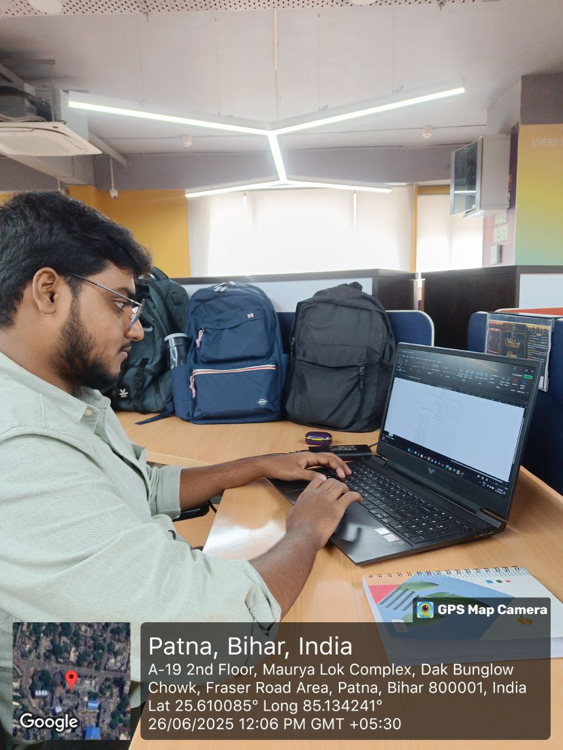
OFFICE
FACTORY
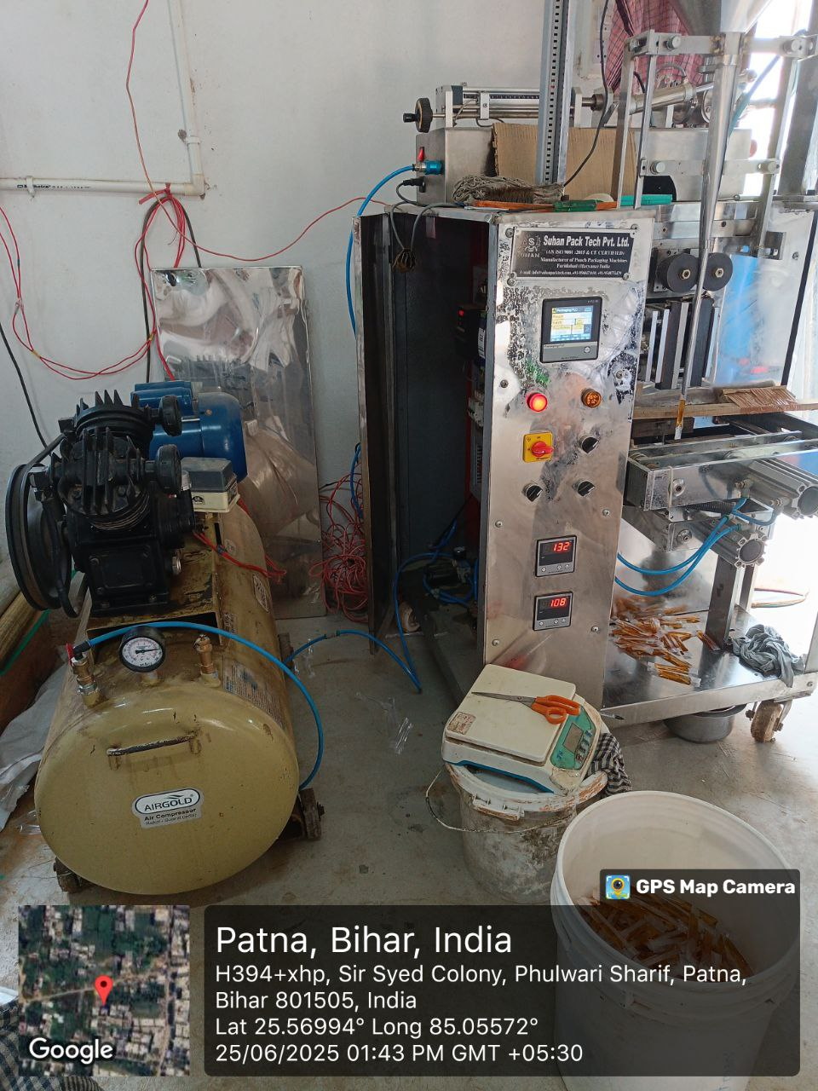
RECEIVING CERTIFICATE
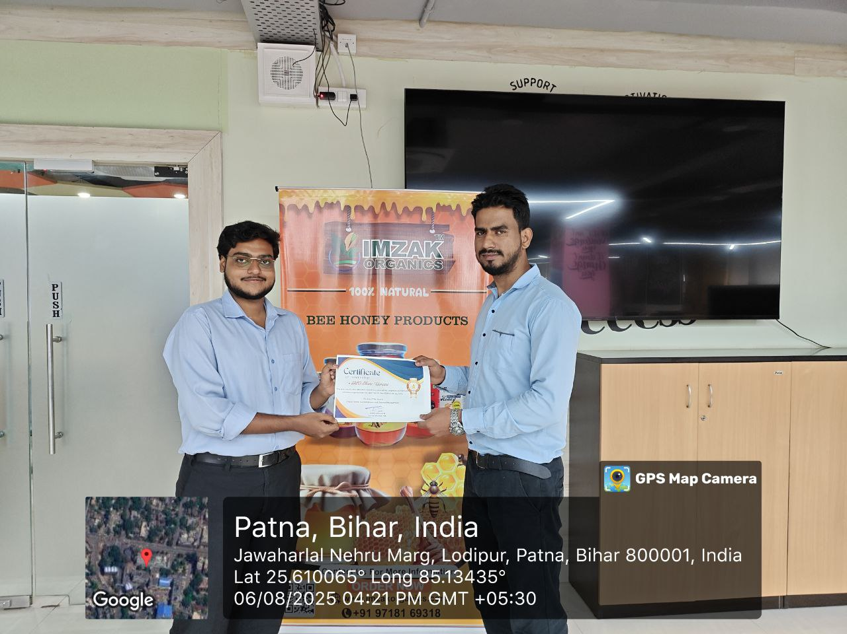
BIHAR INDUSTRIAL ASSOCIATION

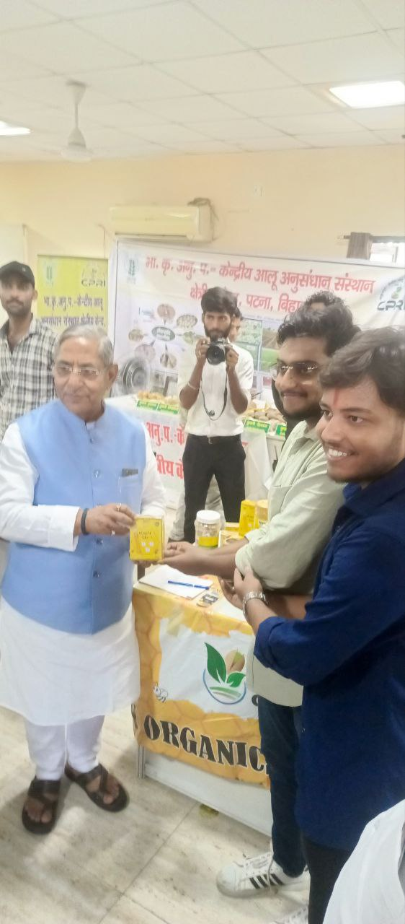


UPENDRA MAHARATI SHILP

